Contents

[41. EditConfig in AEM 2](#_Toc68908236)

[42. Rich Text Editor in Touch UI Dialog Box in AEM 4](#_Toc68908237)

[43. Adding find, replace, subscript, and superscript functionality in Rich Text Editor in AEM 7](#_Toc68908238)

[44. Adding spell check functionality in Rich Text Editor in AEM 8](#_Toc68908239)

[45. Design Dialog + Difference between Normal Dialog and Design Dialog 9](#_Toc68908240)

[46. Create a Design Dialog 14](#_Toc68908241)

[47. Reading values from Design Dialog 17](#_Toc68908242)

[48. Create a Hero component using file upload field 19](#_Toc68908243)

[49. editConfig (drag and drop functionality) 23](#_Toc68908244)

[50. Internationalization (i18n) – Part 1 25](#_Toc68908245)

[51. Internationalization (i18n) – Part 2 26](#_Toc68908246)

[52. Internationalization in Touch dialog box in AEM 28](#_Toc68908247)

# 41. EditConfig in AEM

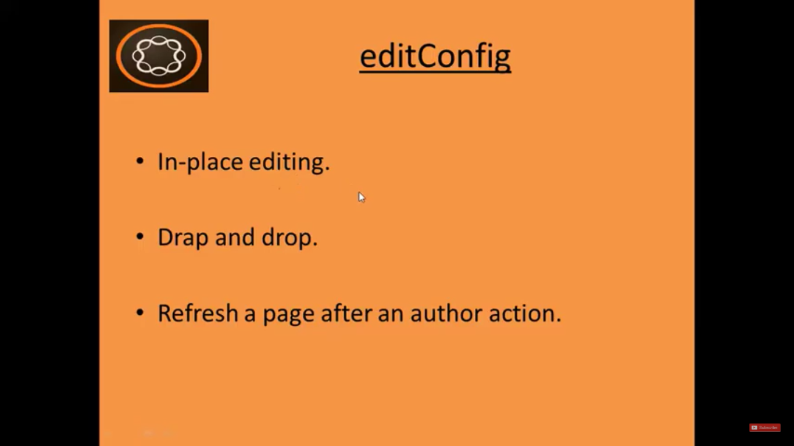

**cq:editConfig** node (we created in last section) is **used to implement** a feature called In-Place editing

Go to the **Page** --> **Click** on **title** --> **Click** on **Pencil** icon --> Then you can directly edit this component without using dialog box.

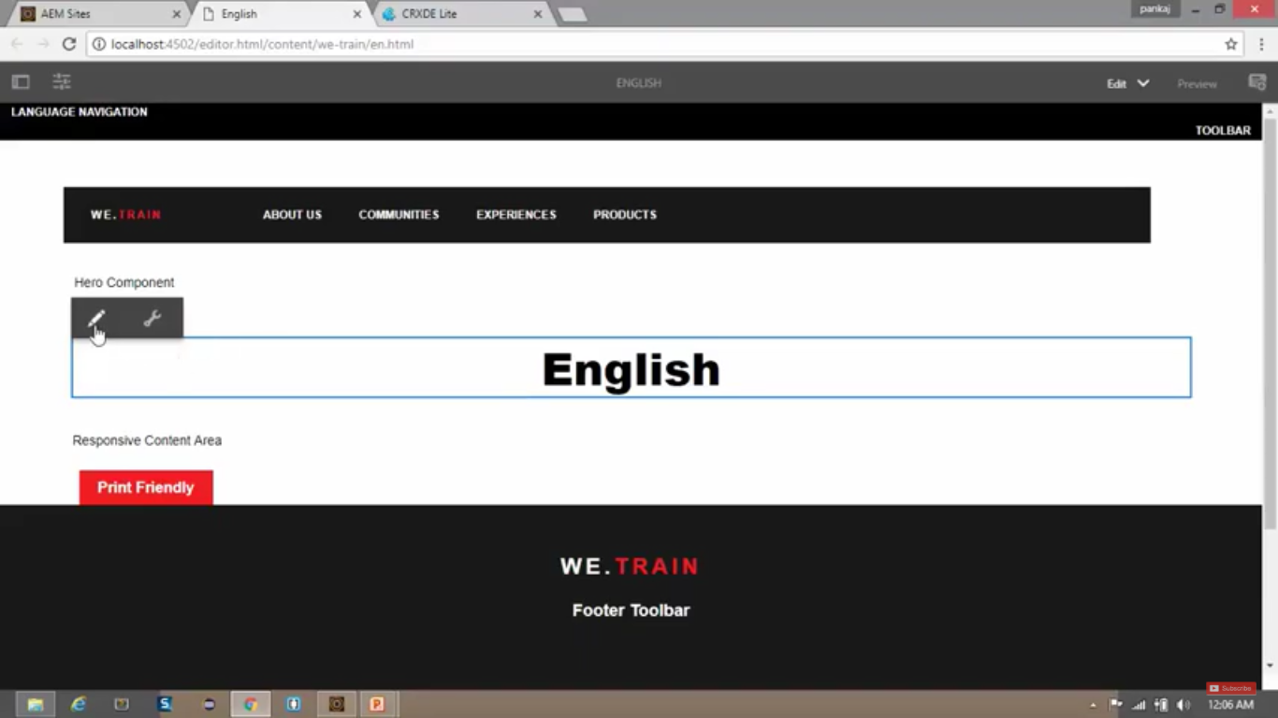

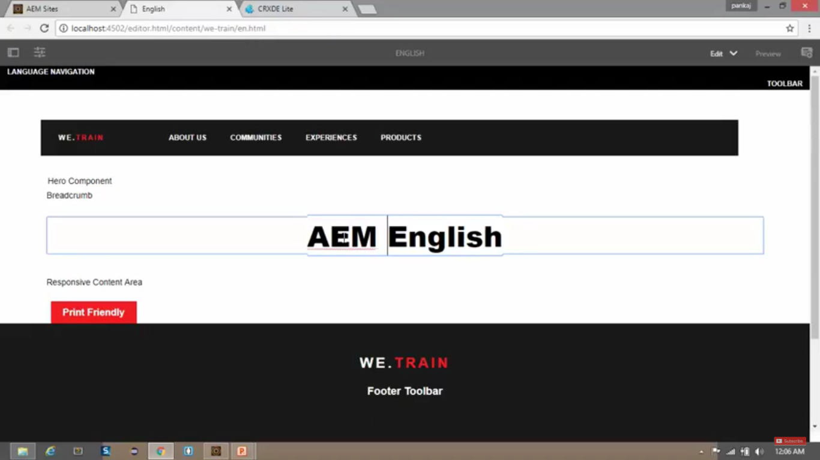

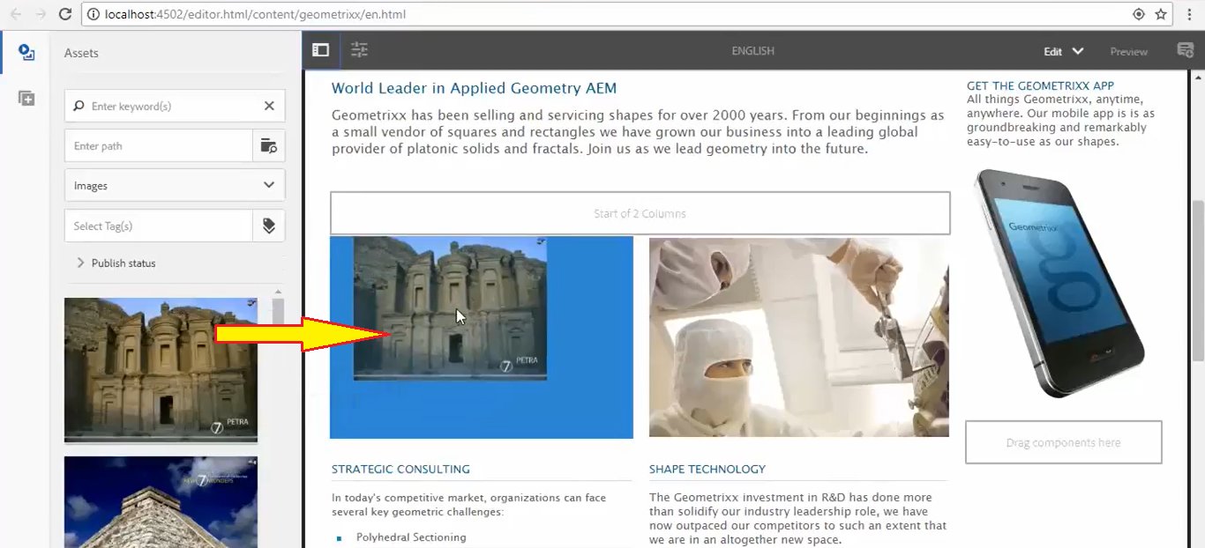

You can also Drag and Drop **images** from **Assets** section to your components image area, **without opening** *dialog box*. (as shown in ***above image***)

In Short, **EditConfig** functions similar as **cq:editConfig.**

Perform below steps, **to add** In-Place editingfor a **component** having **cq:editConfig** node

1. **Right click** on **/apps/training/components/content/title/cq:editConfig** --> **Create** --> Create **Node**

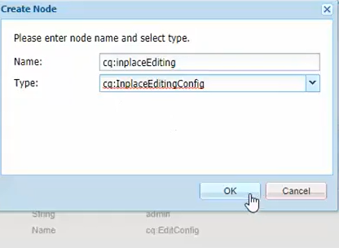

1. **Create** below **2 properties** for same node from Properties Pane. Click on **Save**.

|  |  |  |
| --- | --- | --- |
| **Field Name** | **Type** | **Value** |
| Active | Boolean | True |
| editorType | String | Title |

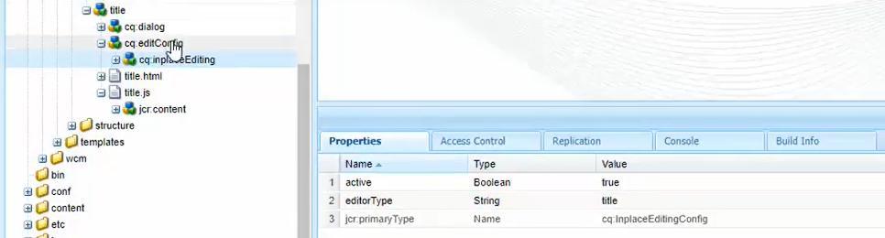

1. **Right click** on **cq:inplaceEditing** --> **Create** --> Create **Node** --> Name **Config** --> Type **nt:unstructured**

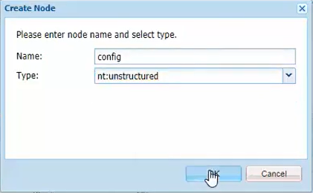 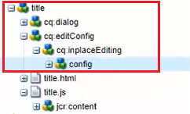

**Conclusion:**

You can **edit** the **title** of the page, by clicking on **Pencil** icon, **without opening** the dialog box.

# 42. Rich Text Editor in Touch UI Dialog Box in AEM

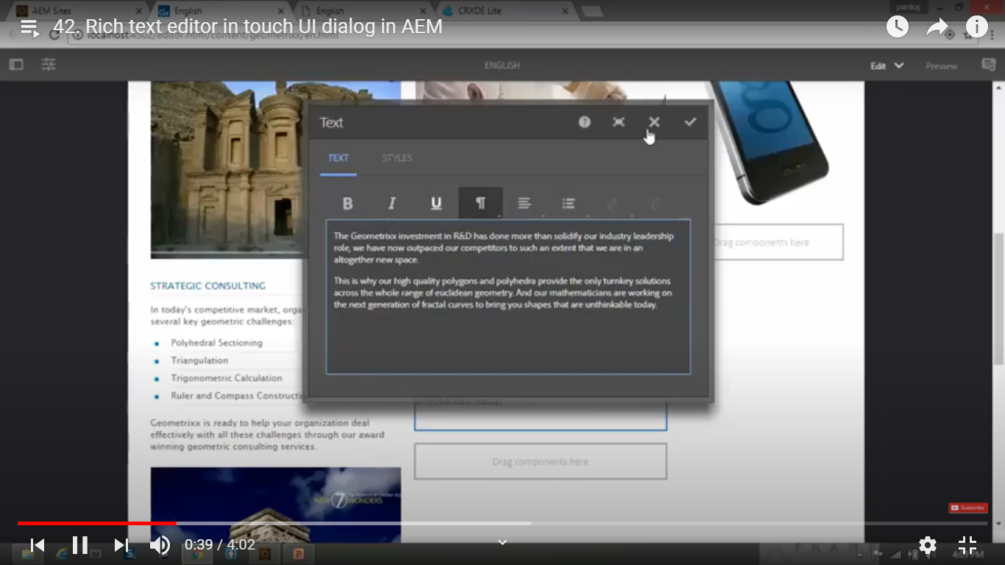

You can make font **BOLD**, **Italic**, **Underlined**. You can change the **alignment** to *Left*, *Centre* and *Right*.

You can add the list, etc using **Rich Text Editor** in **Touch UI** Dialog box.

We can apply similar **Rich Text Editor** on our **title** *component* of the page using following steps:

1. Go to <Chrome://flags> --> **Disable** “Touch Events API” --> **Relaunch** the Chrome browser.

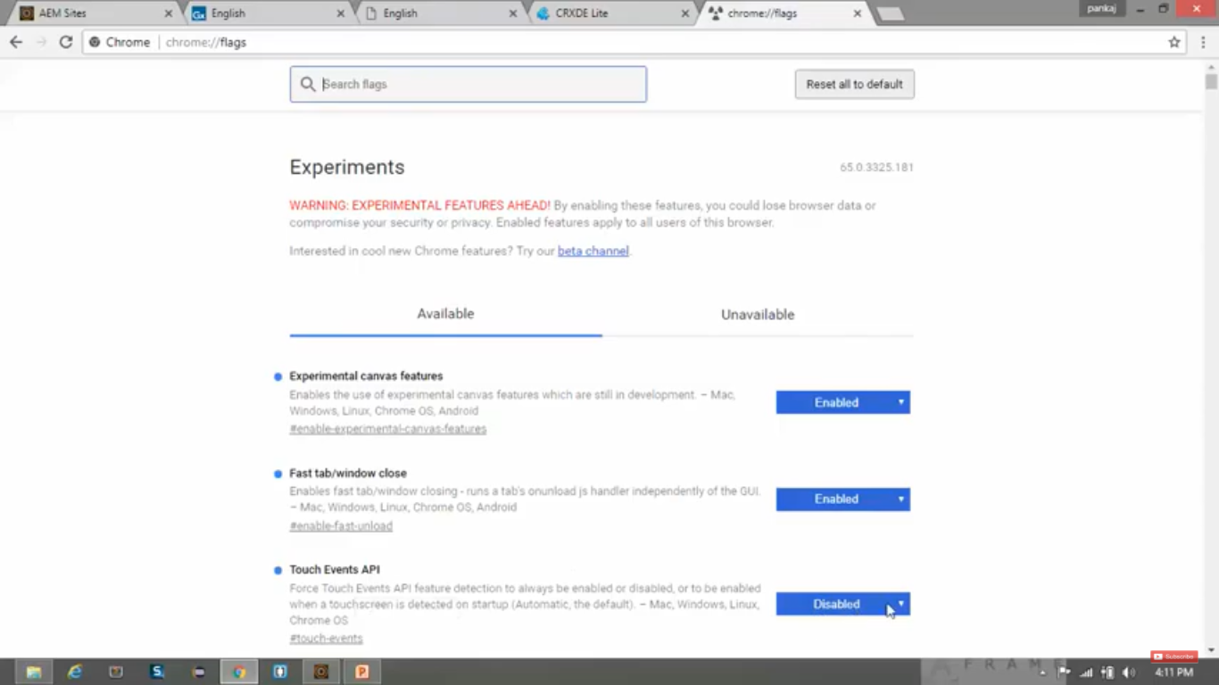

1. Go to **/apps/training/components/content/title/cq:dialog/content/items/column/items/title**
2. **Set** below **property-value** pair.

|  |  |
| --- | --- |
| **Field** | **Value** |
| sling:resourceType | cq/gui/components/authoring/dialog/richtext |

1. **Copy** the **2 nodes** named **rtePlugins** and **uiSettings** from **below** **path**. **Paste** in path mentioned -Step 3. </libs/foundation/components/text/cq:dialog/content/items/tabs/items/text/items/column/items/text>
2. Click on **Save All** button. This process is called **Overlaying**.
3. Copying content from **/*libs***and pasting to **/*apps*** is known as **overlay**.

This ability to override default functionality is called an **overlay**.

1. In **overlay** feature, the **entire tree** is **copied** and **pasted** including its **parent** and **all child** nodes.

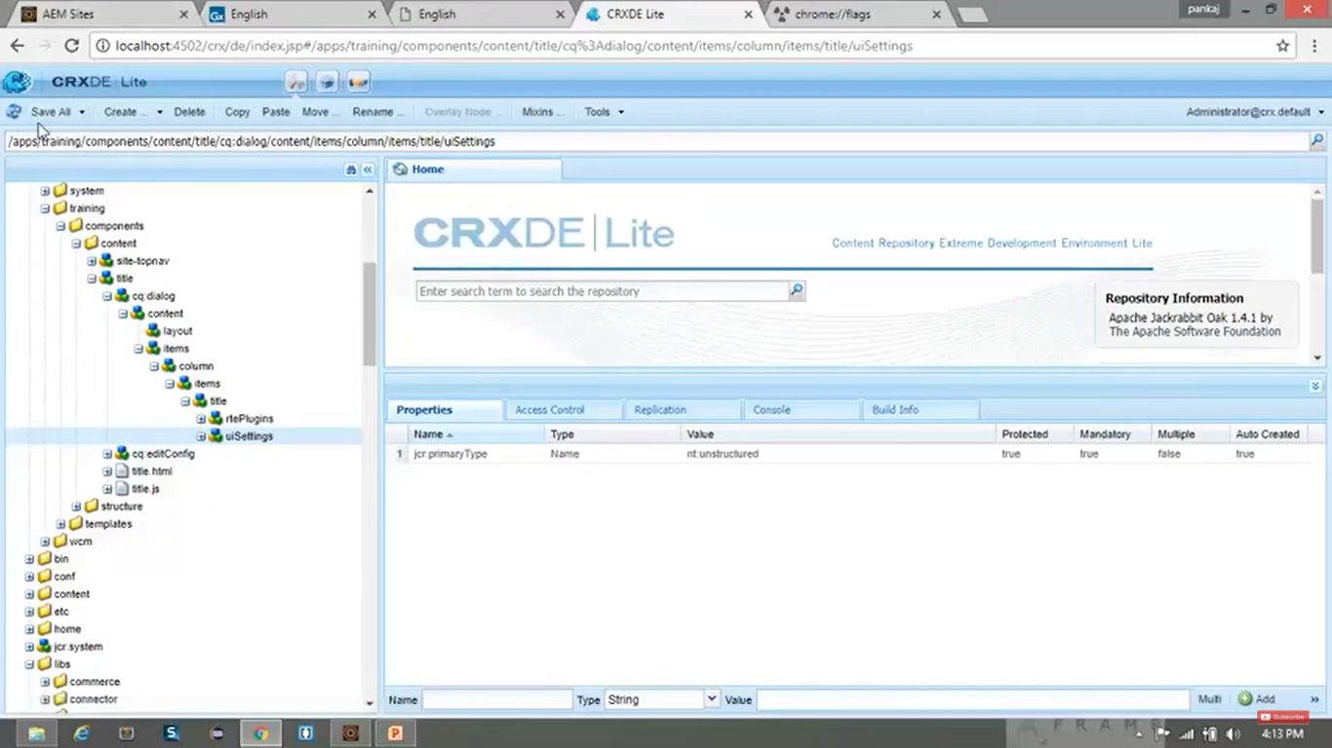

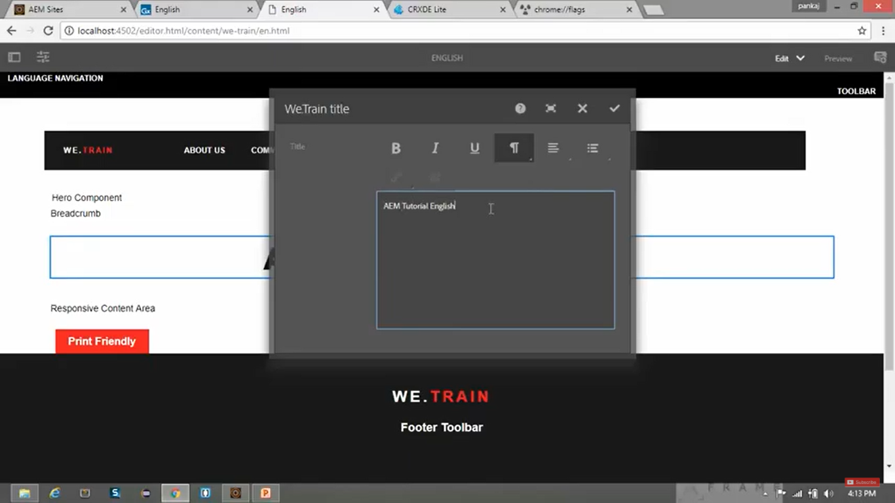

When we **edit** the text in **RTE** and **save**, it will add extra HTML tags. We will solve this issue in next point.

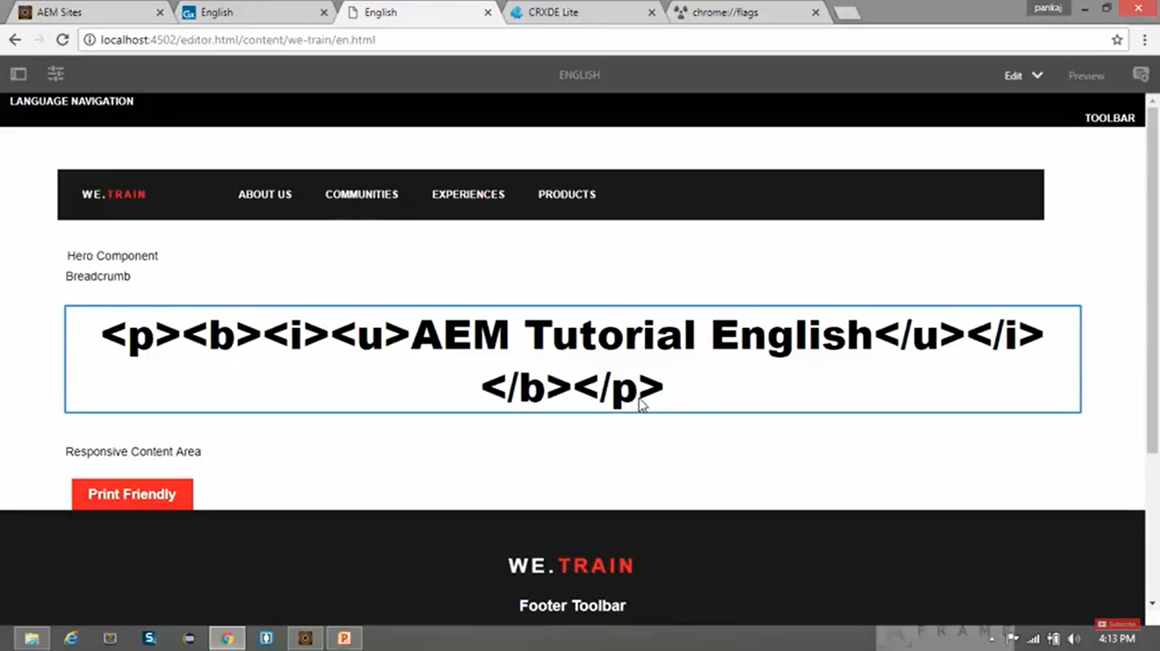

1. Go to **CRX/DE** path </apps/training/components/content/title/title.html>
2. Replace code in **title.html** with below code and click on **Save All** button.

**Before:**

<h1 data-sly-use.title="title.js">${title.text}</h1>

**After:**

<h1 data-sly-use.title="title.js">${title.text @content=’html’}</h1>

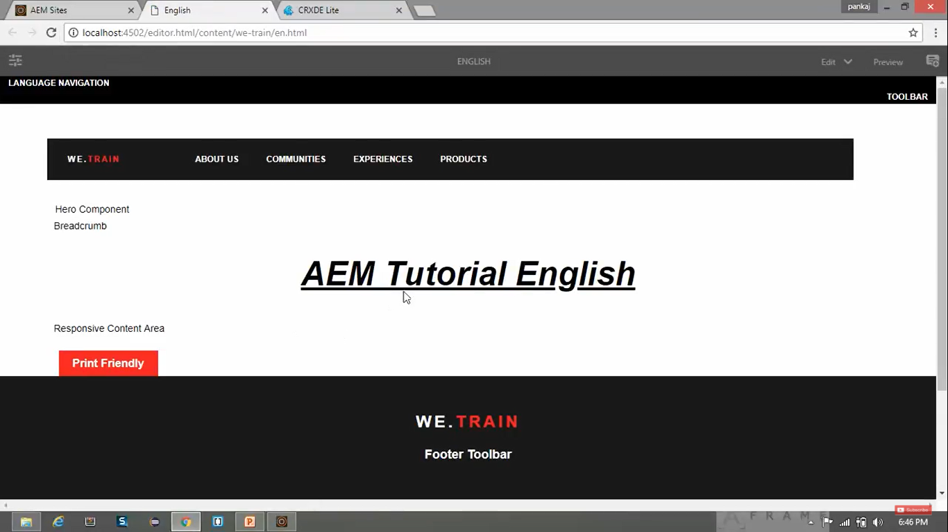

# 43. Adding find, replace, subscript, and superscript functionality in Rich Text Editor in AEM

1. **Right click** on **CRX/DE** node </libs/foundation/components/text/cq:dialog/content/items/tabs/items/text/items/column/items/text/rtePlugins> --> **Create** --> Create **Node** --> **2 times**

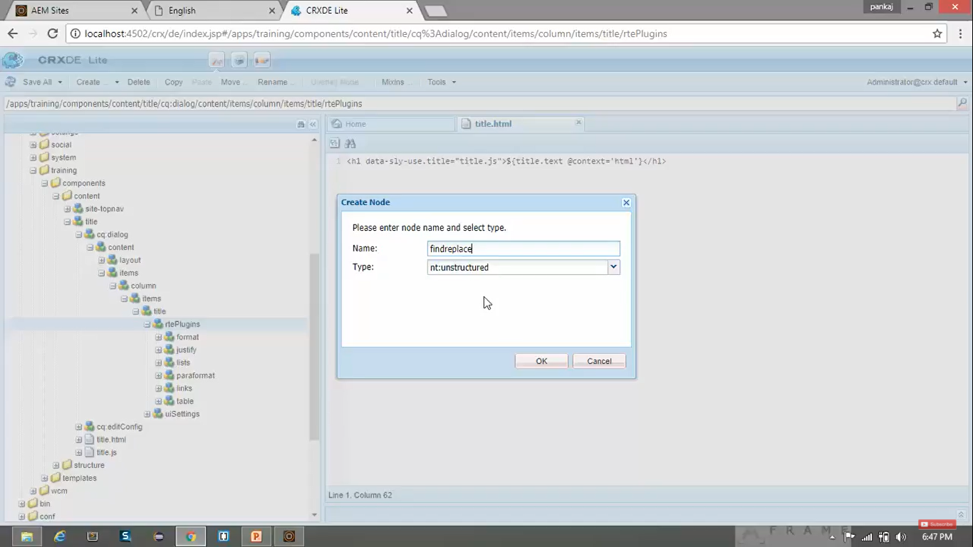 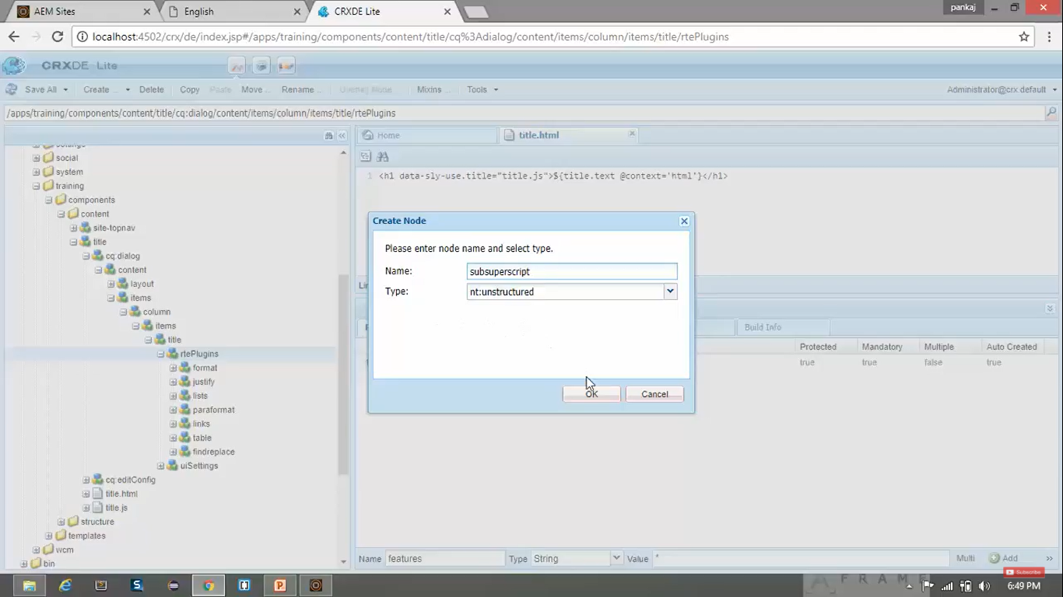

1. Set below **property-value** pair for both the **new** nodes.

|  |  |  |
| --- | --- | --- |
| **Field** | **Type** | **Value** |
| features | String | \* |

1. This above **features**-property defines **which *features* of the plugin are activated**.
2. **To enable all the features**, you may provide value as “**\***”.
3. **Click** on **Save All** button.
4. **Select** the **CRX/DE** node </apps/training/component/content/title/cq:dialog/content/items/column/items/title/uiSettings/cui/inline>
5. Go to **Properties Pane** --> **Double Click** on value of property **toolbar**.
6. **Add** below **4 new values**

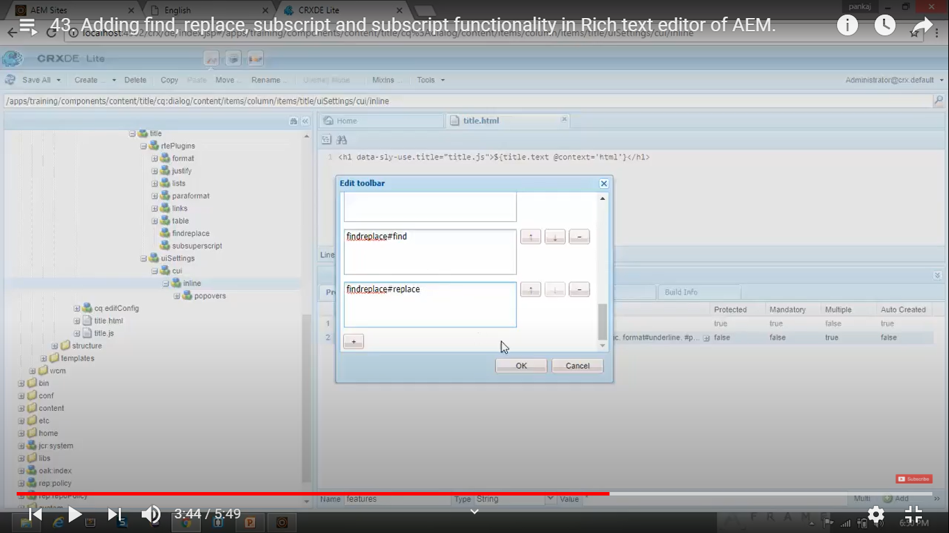 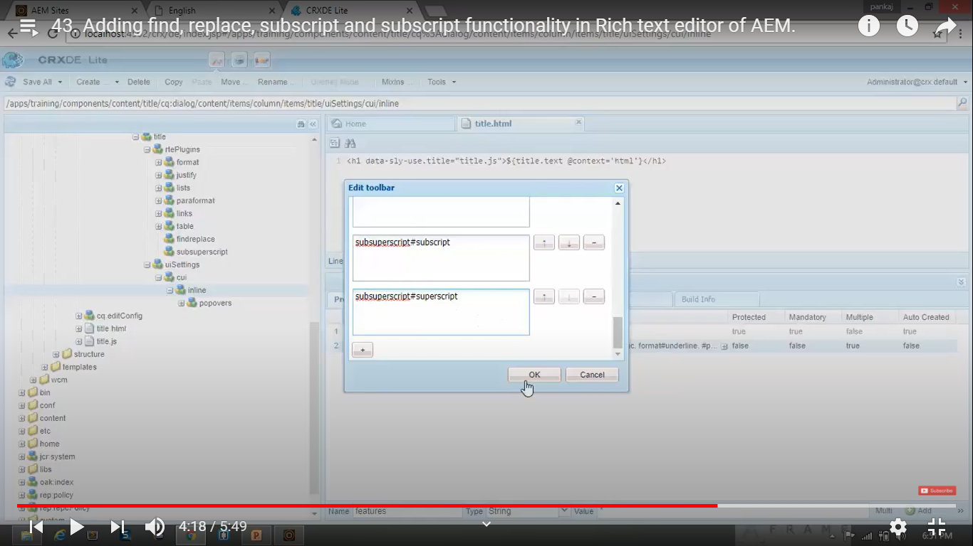

**OUTPUT:**

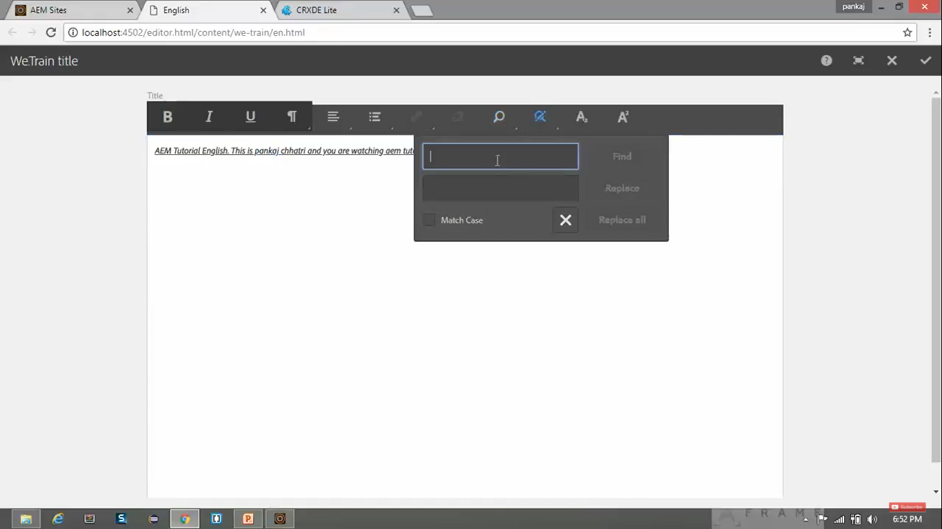

You can see **4 new features** have been **added** to the **RTE** (i.e. **find**, **replace**, **subscript** and **superscript**)

# 44. Adding spell check functionality in Rich Text Editor in AEM

1. **Right click** on </libs/foundation/components/text/cq:dialog/content/items/tabs/items/text/items/column/items/text/rtePlugins> --> **Create** -->Create **Node** -->

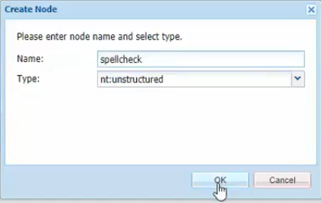

1. **Set** below **property-value** pair for the **new** node.

|  |  |  |
| --- | --- | --- |
| **Field** | **Type** | **Value** |
| features | String | \* |

1. This above **features**-property defines **which *features* of the plugin are activated**.
2. **To enable all the features**, you may provide value as “**\***”.
3. **Click** on **Save All** button.
4. **Select** the **CRX/DE** node </apps/training/component/content/title/cq:dialog/content/items/column/items/title/uiSettings/cui/inline>
5. Go to **Properties Pane** --> **Double Click** on value of property **toolbar**.
6. **Add** below **new value** named spellcheck#checktext

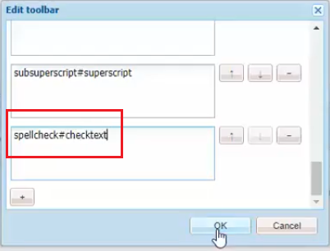

**OUTPUT:**

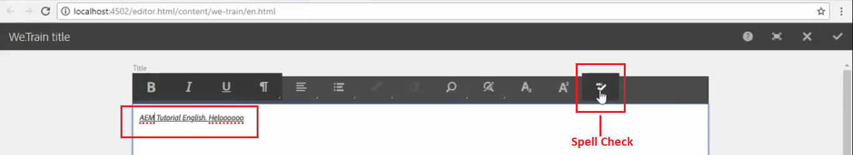

# 45. Design Dialog + Difference between Normal Dialog and Design Dialog

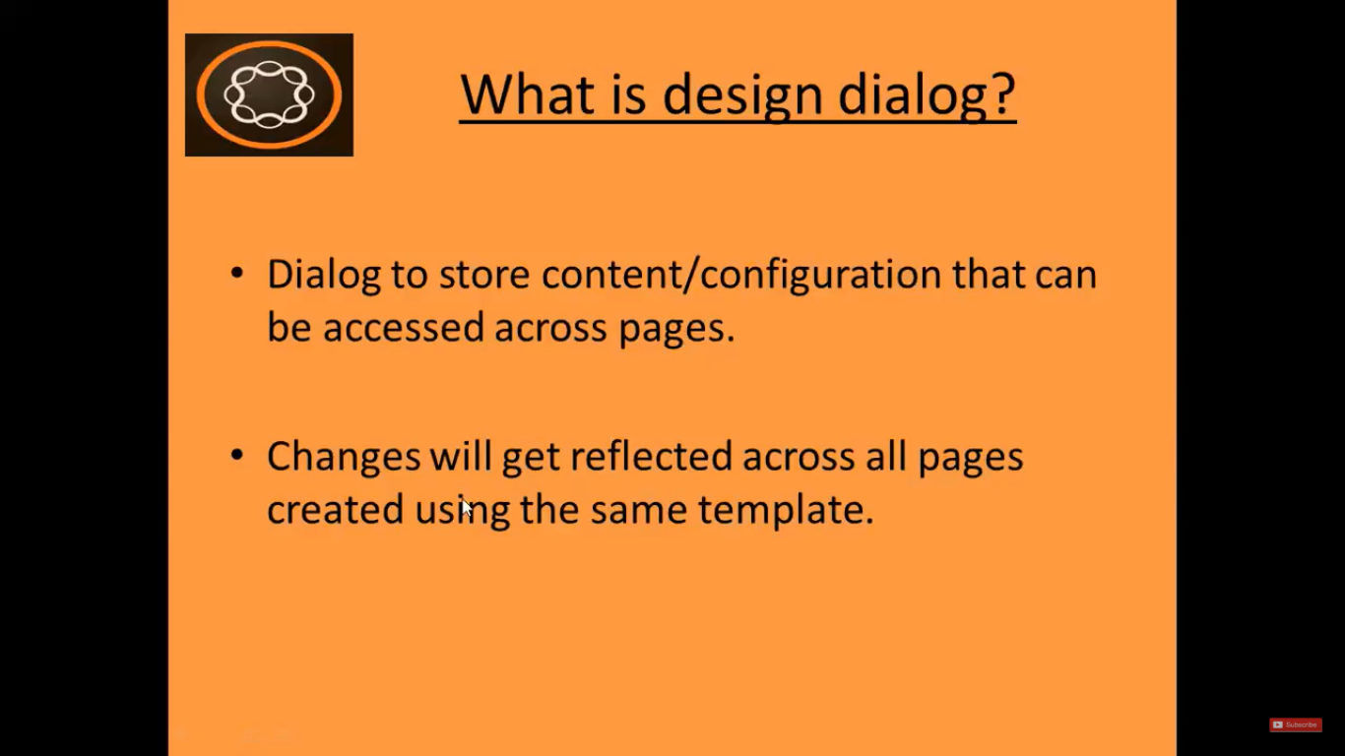

1. **Design dialog** is a Dialog **to store content/configuration** that can be **accessed across pages**.
2. It is used, when we require a **Component** whose **Content** or **Configuration** should be **same throughout the application**, and which are **created using same template name**.
3. **For example**, you can **create logo** component using design dialog, because the logo will be same throughout entire application.
4. **Changes** made in **Design Dialog** will get reflected **across all pages** created using this **same template**.

**To check how Design Dialog looks like:**

Go to **AEM** --> **Sites** --> **Geometrixx** Site --> **English** --> **Products** Page --> Click **Edit** button to open the page

Go to **AEM** --> **Sites** --> **Geometrixx** Site --> **English** --> **Products** Page --> **Triangle** Page --> Click **Edit** button to open the page.

**Open** these **pages** in **Design Mode** by selecting it from **dropdown** on top (as shown below image).

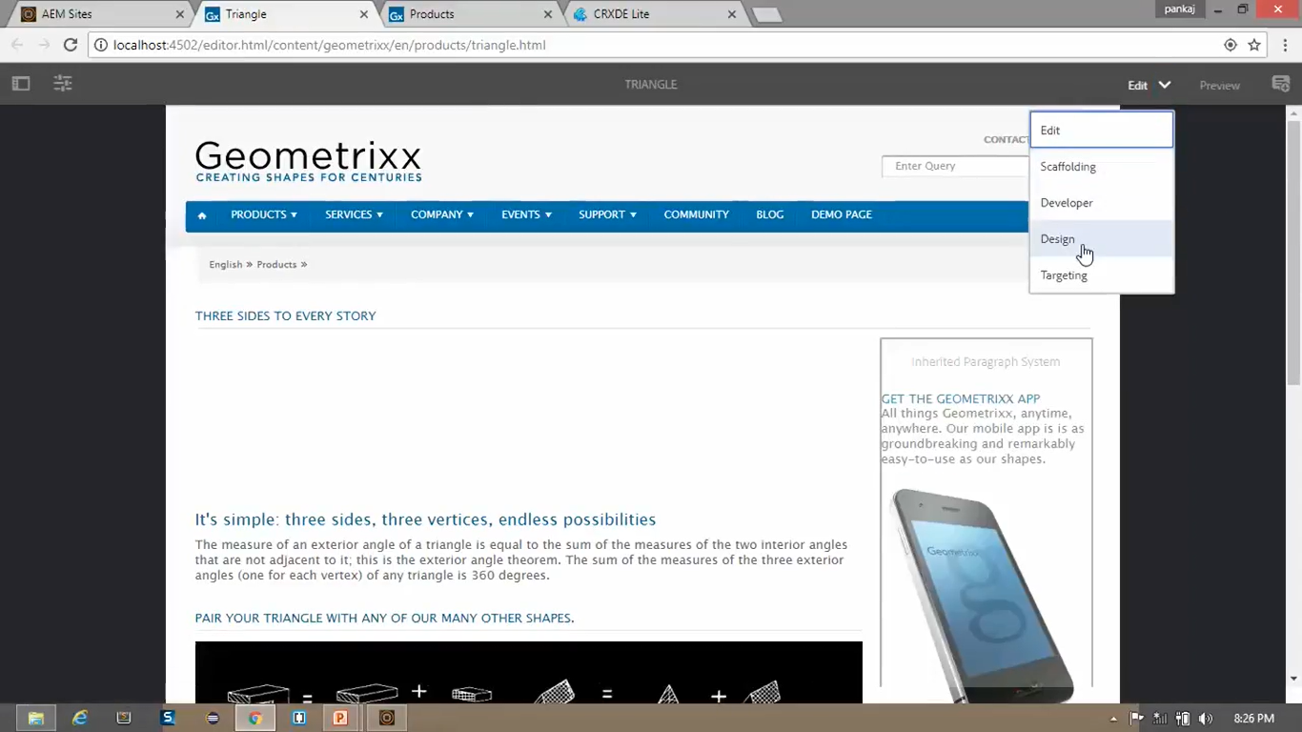

Click on **Edit** icon on **title** of **both pages**. It will open **Edit Dialog**.

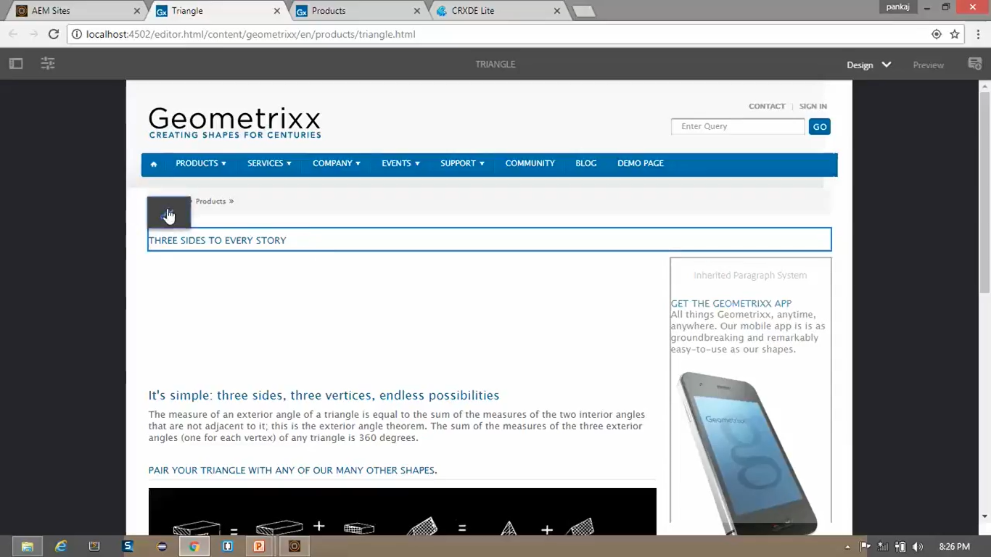

**Default Type** is set to **Small** for page **title**.

We can **change** this **Default Type** field to value **Extra Large** on **Triangle** Page.

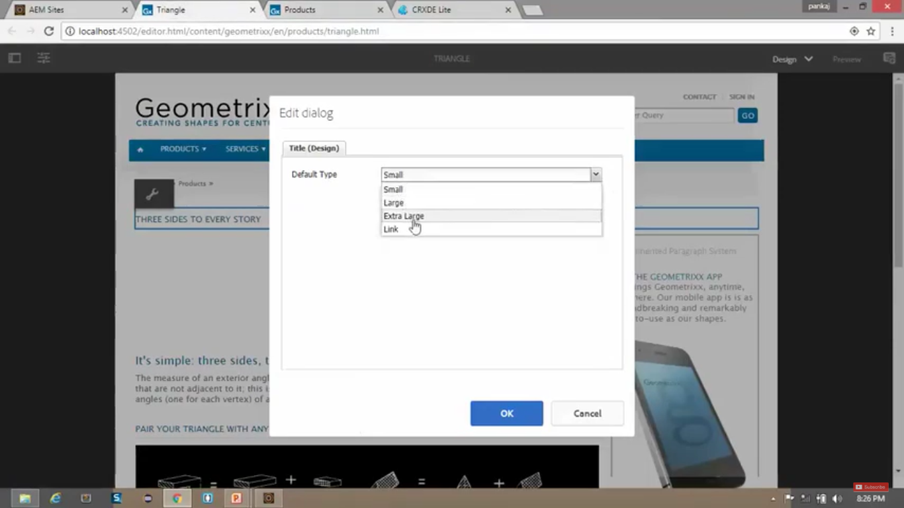

Now, **change** has been **reflected** on **both** the **pages** i.e. **Triangle** and **Products** page.

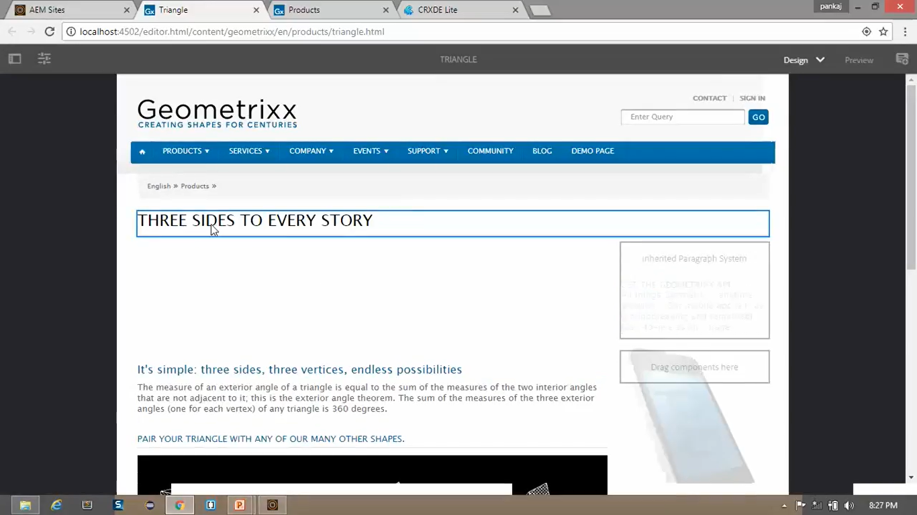

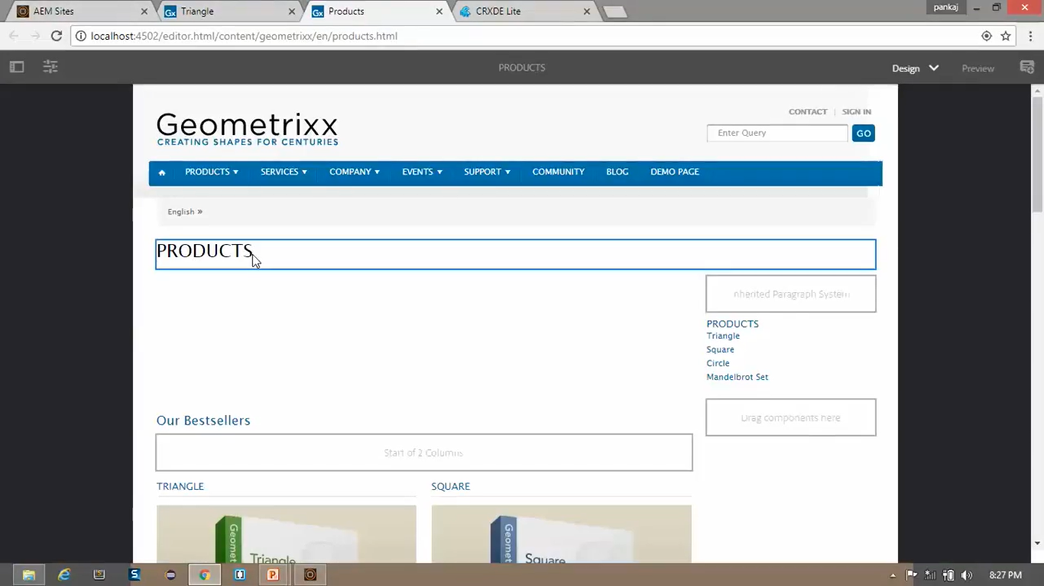

**Conclusion:**

This way, the **changes** to the **Design Dialog** will get reflected **across all the pages** that are created using **same template**.

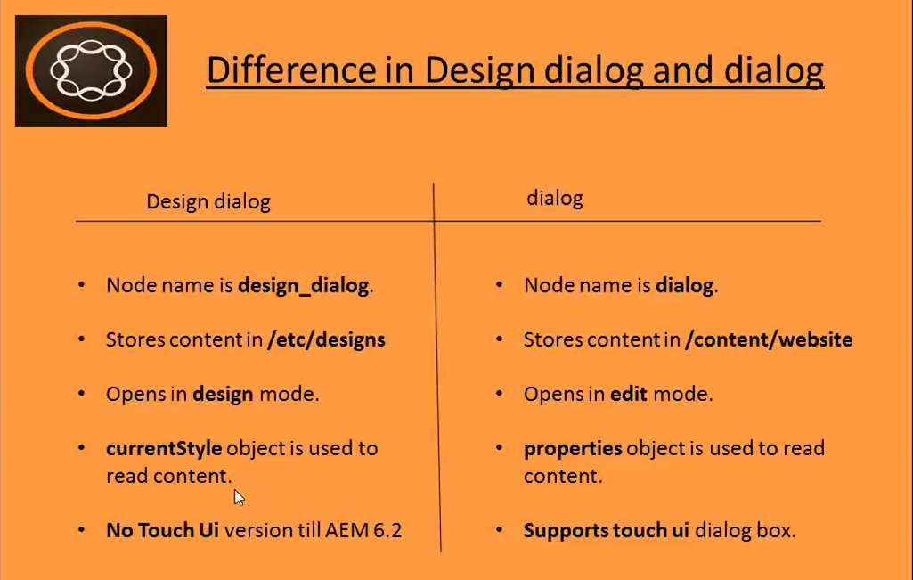

^

**VIMP**

**NOTE:** **Touch UI** version is available for **Design Dialog** from **AEM 6.3** and **onwards**.

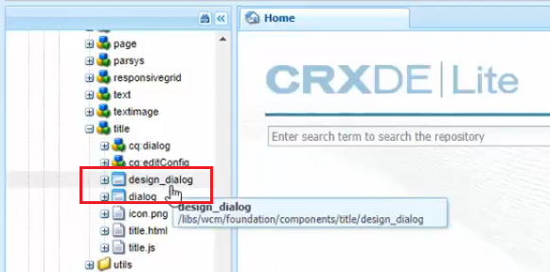

# 46. Create a Design Dialog

1. We create **Design Dialog** for **global components**, or when we want our **changes** to be reflected **across all the pages** which are using **same template**.
2. **Currently** we have implemented **normal dialog**, **but** now we will implement it using **Design Dialog**.
3. **Currently**, **if** we **change** the **style** of the **title component** in **any page**, it will **not change** the **style** of the **title component** on **other pages**.
4. If you want **to see** the **changes** across **all the pages** which are **created using** the **same template**, then you **need to use** --> **Design Dialog**.
5. **To change** it to **Design Dialog**, **Right click** on **CRX/DE** node </apps/training/components/content/title>

--> **Create** -->Create **Dialog**

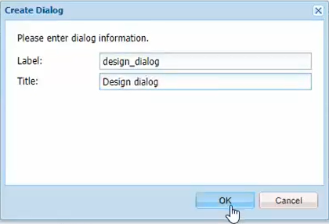

1. Click on **Save**.
2. **Right click** on **CRX/DE** node </apps/training/components/content/title/design_dialog/items/items/tab1>--> **Create** -->Create **Node**

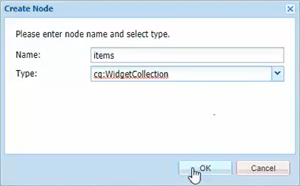

1. **Click** on **Save** button --> The **procedure** is **same** as what we do for a **normal dialog**.
2. **Right click** on node [/apps/training/components/content/title/design\_dialog/items/items/tab1/items](/apps/training/components/content/title/design_dialog/items/items/tab1)

--> **Create** --> **Create Node**

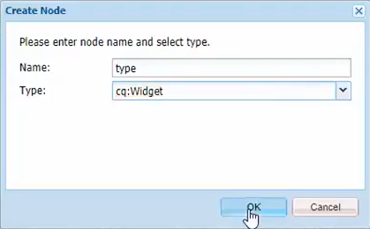

1. **Click** on **Save** button.
2. **Add** below **new properties** to this **newly created node** from Properties Pane.

</apps/training/components/content/title/design_dialog/items/items/tab1/items/type>

|  |  |  |
| --- | --- | --- |
| **Field** | **Type** | **Value** |
| fieldLabel | String | Type |
| name | String | /type |
| type | String | Select |
| Xtype | String | selection |
| defaultValue | String | h1 |

1. Click on **Save**.
2. **Right click** on **CRX/DE** node </apps/training/components/content/title/design_dialog/items/items/tab1/items/type>--> **Create** -->Create **Node** --> **Click** on **Save** button.

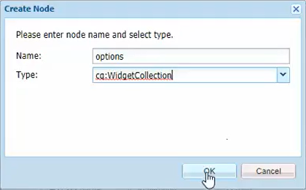

1. **Right click** on **CRX/DE** node </apps/training/components/content/title/design_dialog/items/items/tab1/items/type/options>--> **Create** --> **Create Node**

|  |  |
| --- | --- |
| **Field** | **Value** |
| Name | h1 |
| Type | nt:unstructured |

1. **Add** below **new properties** to this **newly created node** from Properties Pane.

</apps/training/components/content/title/design_dialog/items/items/tab1/items/type/options/h1>

|  |  |  |
| --- | --- | --- |
| **Field** | **Type** | **Value** |
| text | String | H1 |
| value | String | h1 |

1. **Copy** this **h1** node and **paste** it 3 times. --> **Rename** new nodes with **h2**, **h3**, and **h4**.
2. Also **change** their **properties** according to **their names**.
3. **Open** the **English** page <http://localhost:4502/content/we-train/en.html>.
4. **Click** to select **Design** from dropdown present at top right corner to *open page in* **Design mode**.
5. **Click** on **title** component, click on **Edit** icon --> It will **open** the **Design** Dialog box.

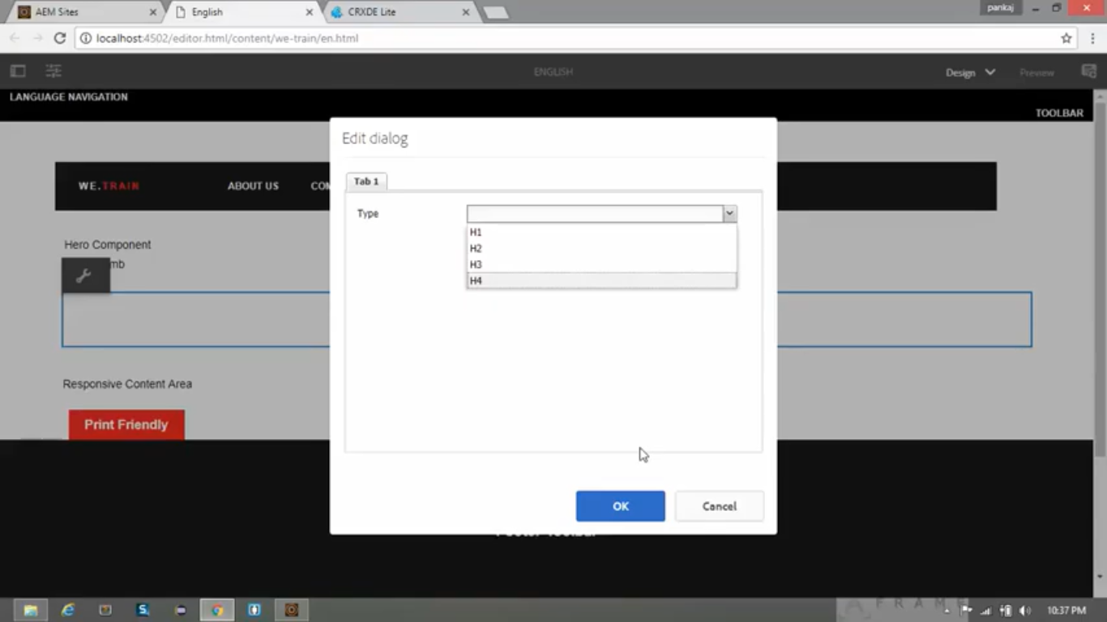

# 47. Reading values from Design Dialog

1. In last section we created Design Dialog on page, **style** of **title** component **did not change** when we change values from **h1 to h4** from design dialog.
2. But in this section, we will **read values** which are set from Design Dialog and we will **write code** to **change style** of **title** component based on the **values user has set** from Design Dialog.
3. When we change values from Design Dialog, it **gets** **changed** in **properties** value and gets stored in CRX/DE.
4. To check the same, go to **CRX/DE** path</etc/designs/training/jcr:content/contentpage/title>
5. Check the **property** of **node** named **type** which will have **value set** to  (We selected it from Design Dialog).
6. In this section we will see how to read this value and apply it to **title** component.
7. Go to **CRX/DE path** </apps/training/components/content/title/title.js>
8. Add below code at line number 17.

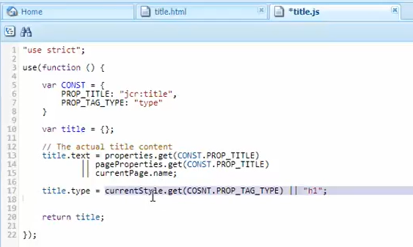

1. **Save** the file.
2. Go to CRX/DE path </apps/training/components/content/title/title.html>
3. **Replace** existing code with below new code.

|  |  |
| --- | --- |
| **Existing Code** | <h1 data-sly-use.title="title.js"> ${title.text @content=’html’} </h1> |
| **New Code** | <h1 data-sly-use.title="title.js" data-sly-**element**=”${title.**type**}”> ${title.text @content=’html’} </h1> |

1. Now **open** the **English** page <http://localhost:4502/content/we-train/en.html>
2. Here you can see that it has used **h3** element to render the title.
3. You can open page in **Design mode** and click on **Edit icon** to select any value from **h1** to **h4**.
4. It will **render** the **selected element** **h3** on page to display **title** in **title** **component** across all the pages.

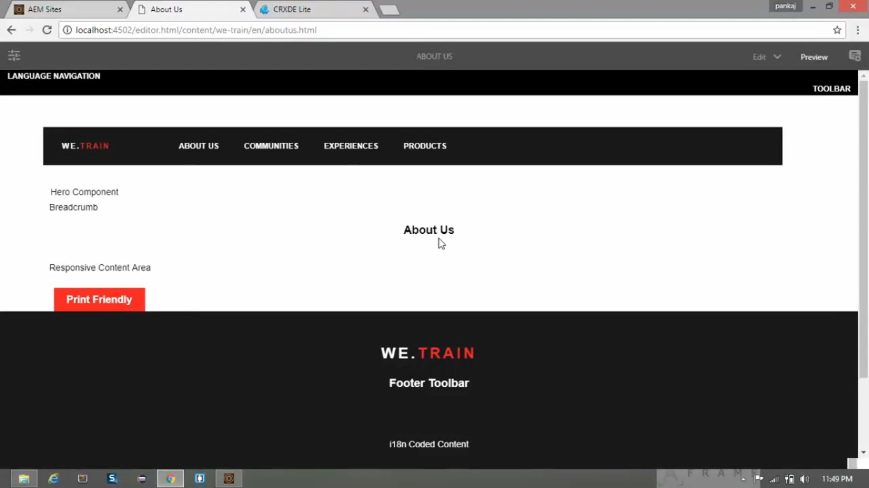

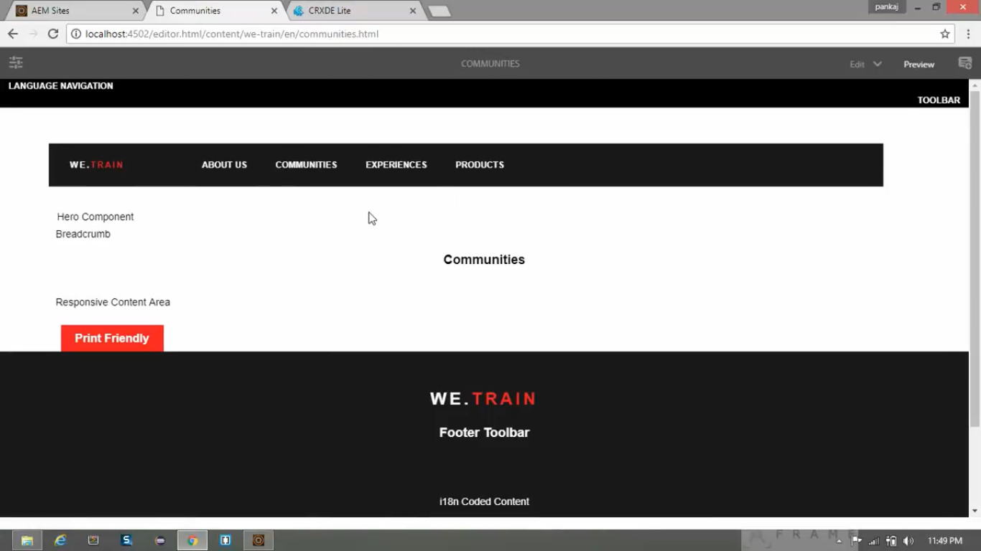

# 48. Create a Hero component using file upload field

**Current Implementation**

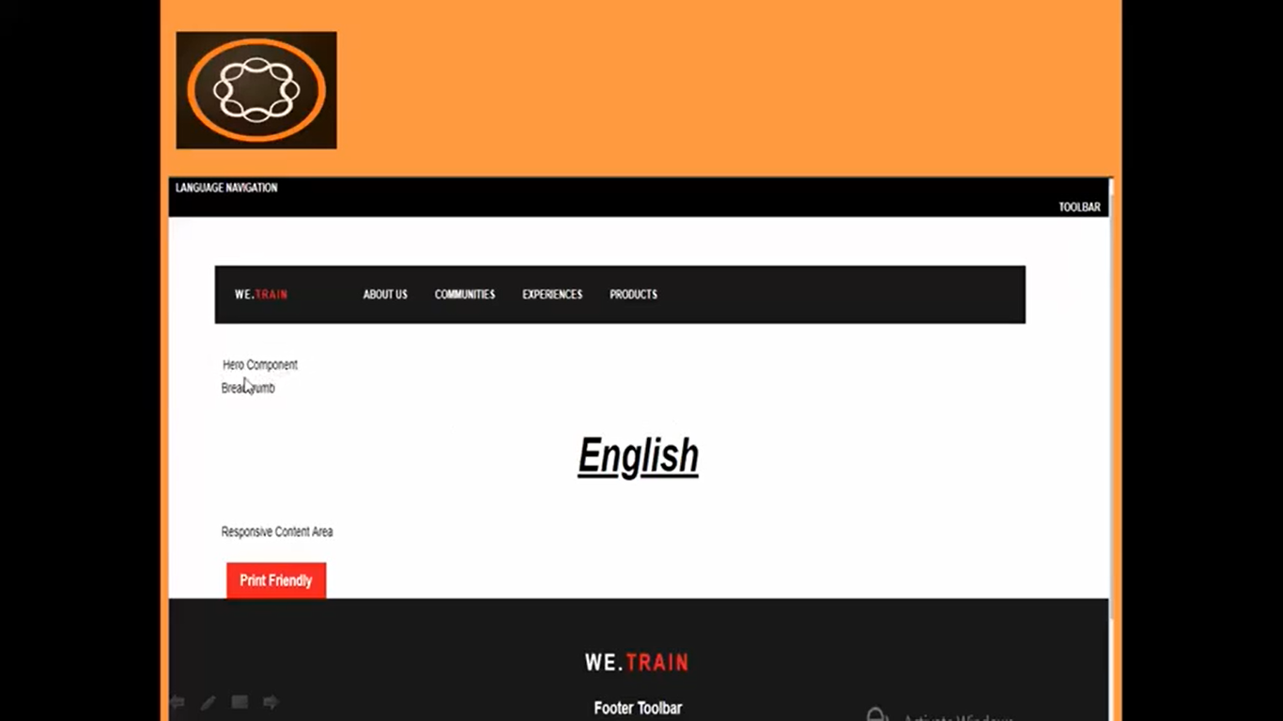

**Expected Implementation**

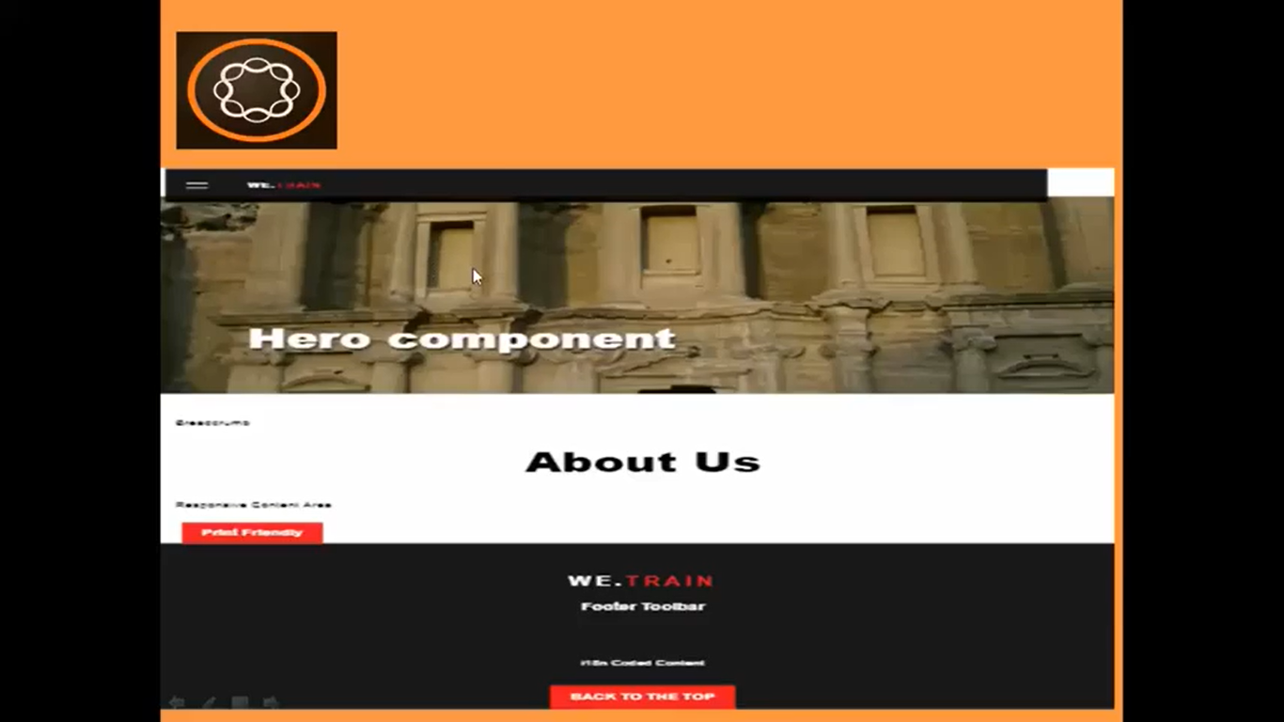

1. Go to **CRX/DE** path </apps/training/components/content> --> Create --> Create Node --> below values

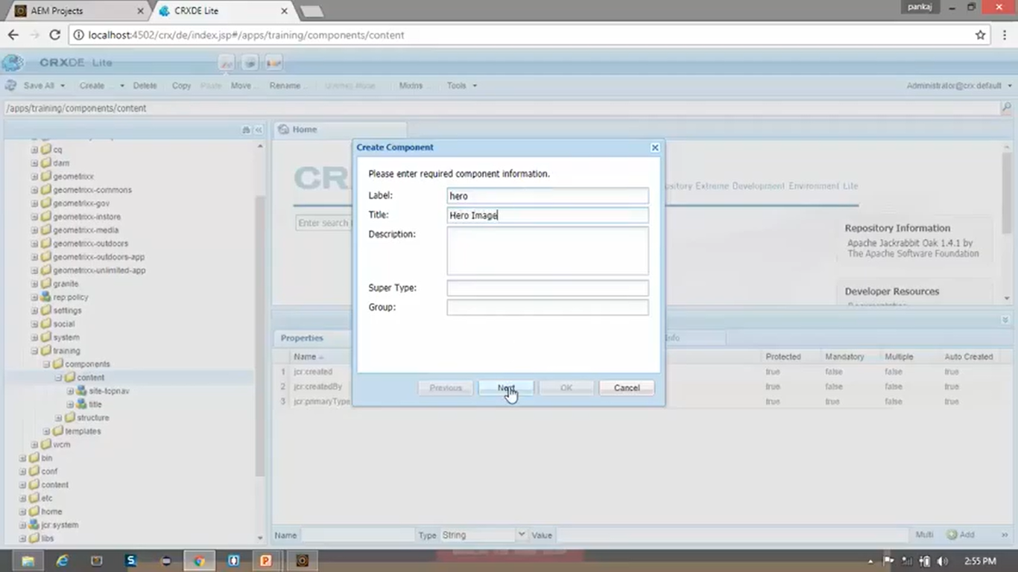

1. Click on **Save All** button.
2. **Rename** node </apps/training/components/content/hero/hero.jsp> to **hero.html**.
3. **Clear** the contents of the file.
4. Go to **CRX/DE** path </apps/training/components/structure/contentpage/body.html>
5. **Replace** existing code at line number **12** with below **new** code.

|  |  |
| --- | --- |
| **Existing Code** | <div> Hero Component </div> |
| **New Code** | <div data-sly-resource="${'hero' @ resourceType='training/components/structure/hero'}"></div> |

1. Now we will **create** dialog box for **Hero** component.
2. **Copy** the node from CRX/DE path </libs/wcm/foundation/components/image/cq:dialog> and **paste** it to </apps/training/components/content/hero> node component.
3. Click on **Save All** button.
4. **Delete** unwanted nodes like “linkURL”, “description” and “size” from path mentioned in below path.

</apps/training/components/content/hero/cq:dialog/content/items/image/items/columns/items>

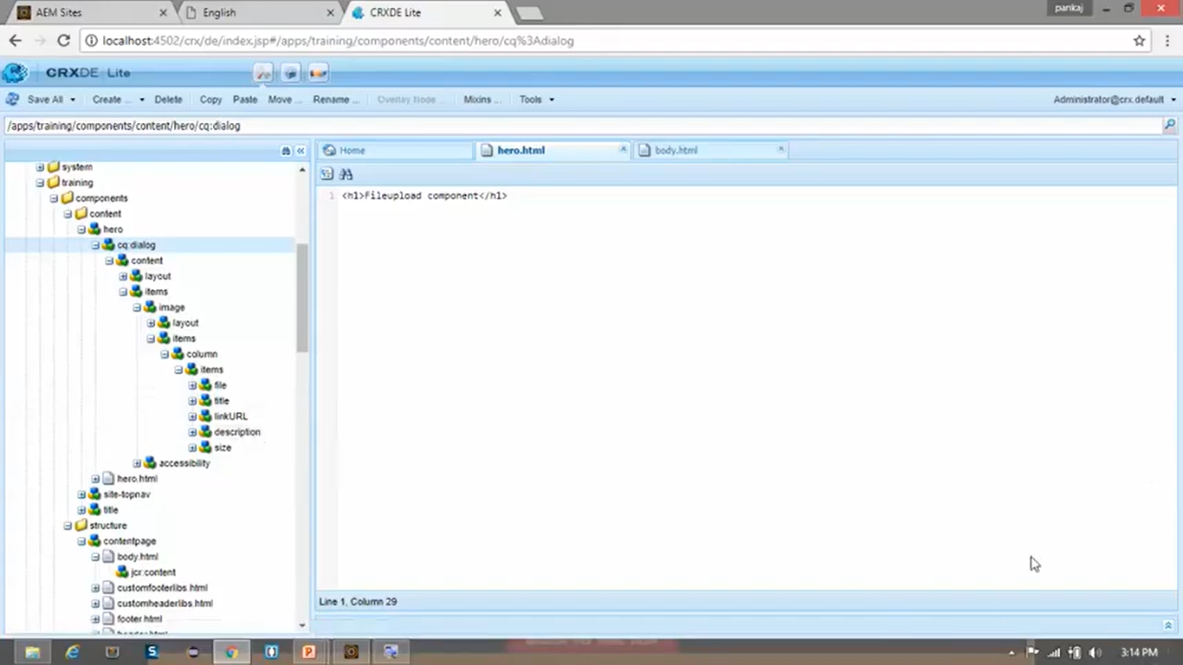

1. To make this file upload component editable, we need to add **editConfig** file in our **Hero** component.
2. Go to CRX/DE path </apps/training/components/content/hero> --> **Create** --> Create **Node**

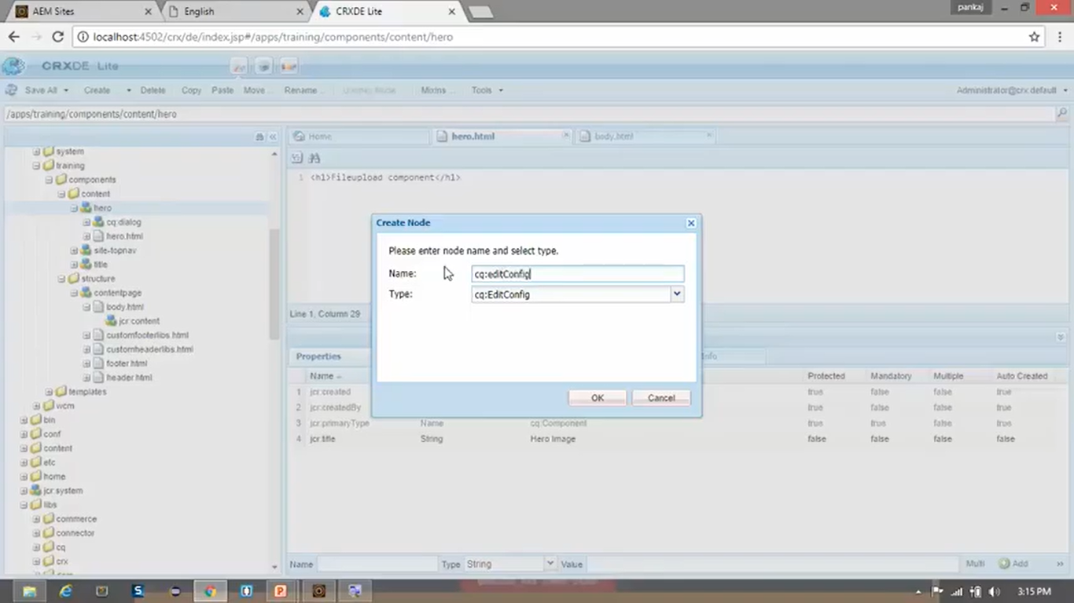

1. Name and Type should **match** with exact values; otherwise it will not work. Click on **OK** button.
2. See contents of the **Hero.html**

<div class="we-HeroImage width-full ratio-16by9" style="background-image:url(${properties.fileReference @ context='styleString'});">

<div class="container cq-dd-image">

<div class="we-HeroImage-wrapper">

<strong class="we-HeroImage-title">${properties.jcr:title}</strong>

</div>

</div>

</div>

1. [VIMP] **Sightly** **does not parse** **JS** and **CSS**. Hence, we set context is to styleString in above code.

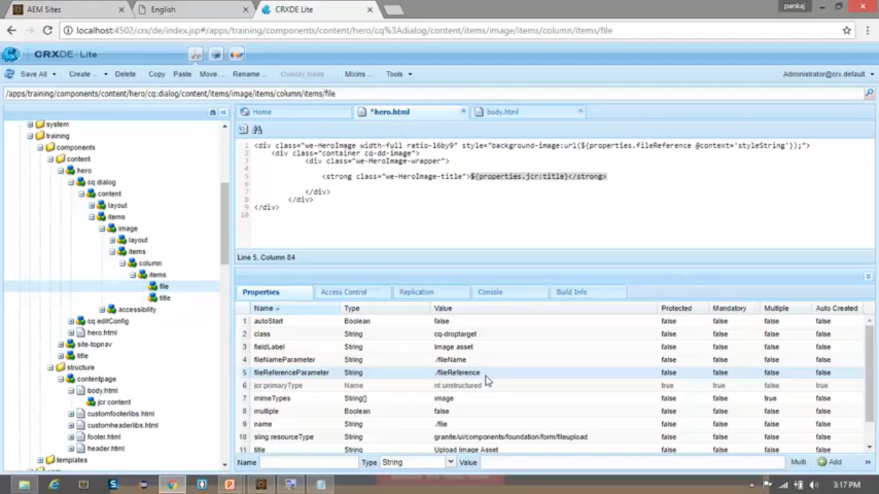

1. You can see (above image) that **fileReferenceParameter** is **set to** **/fileReference**. It stores actual path of the image.
2. It will **replace** **properties.fileReference** by the path.
3. Now if you **open** any **page** you can see that **Hero** component is **visible and editable** as shown below.
4. **Click** on **Edit** icon on **Hero** Component. **Add** **Title** and **Image** and **Click** on **Save** icon (top right)

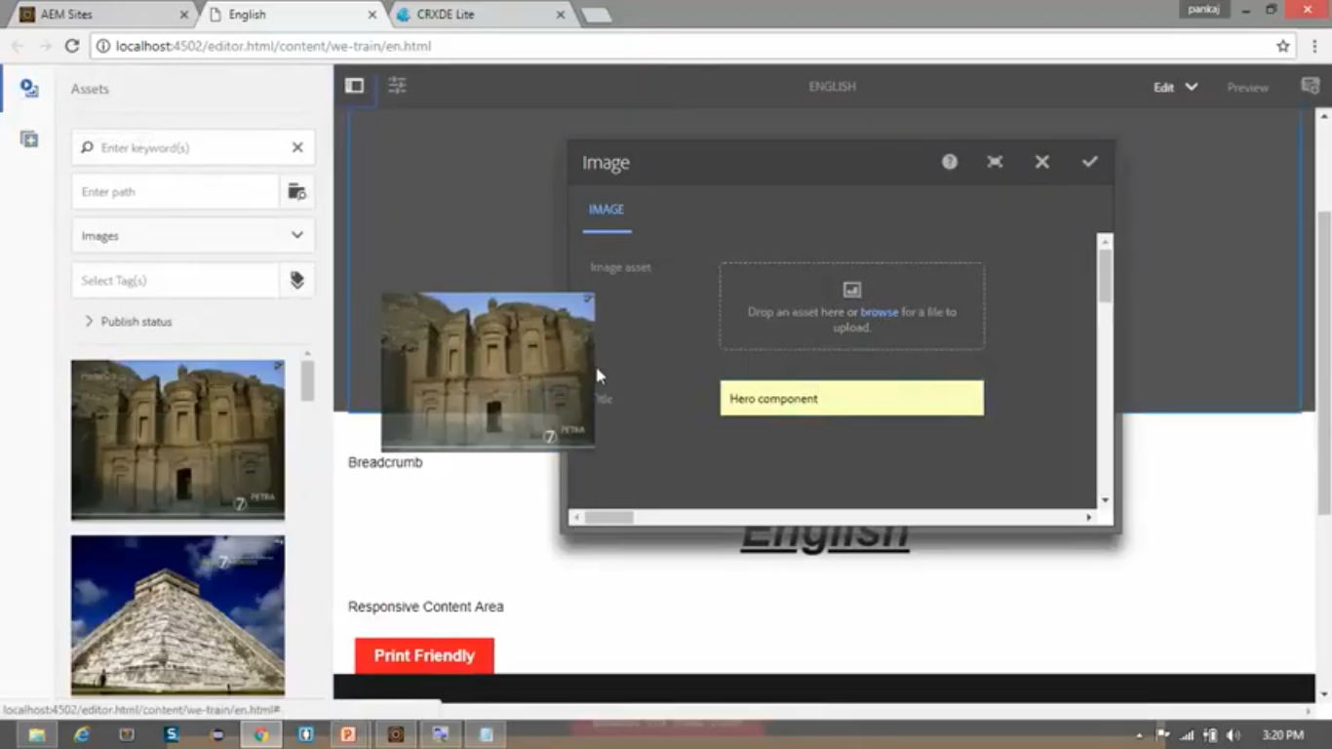

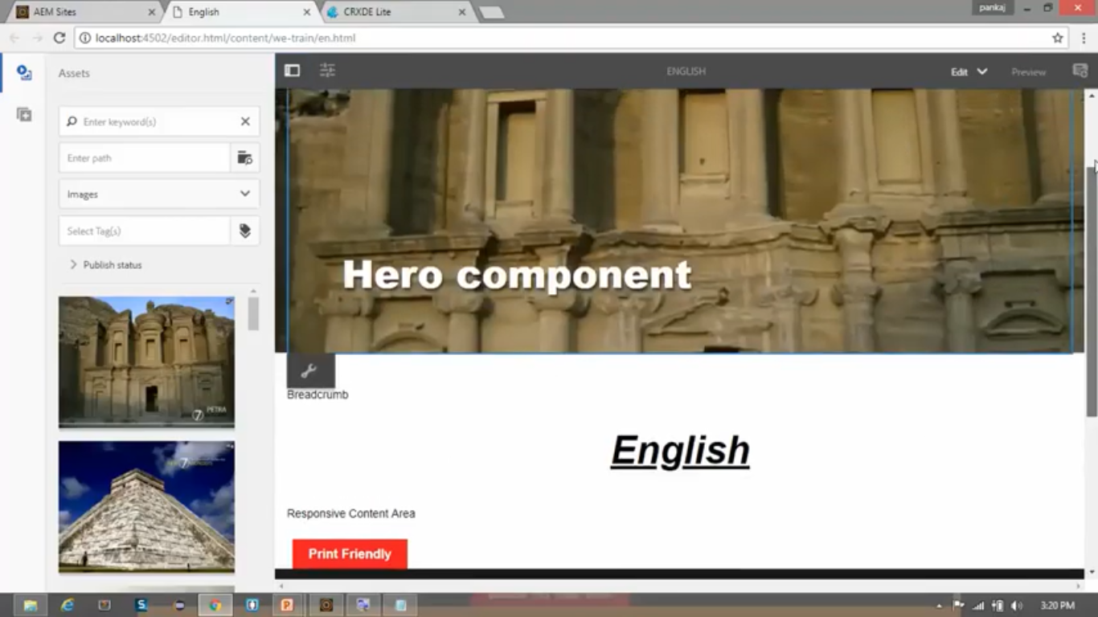

1. You can see (below image) that **image file** **path** is stored in value of **fileReference property** of node </content/we-train/en/jcr:content/hero>

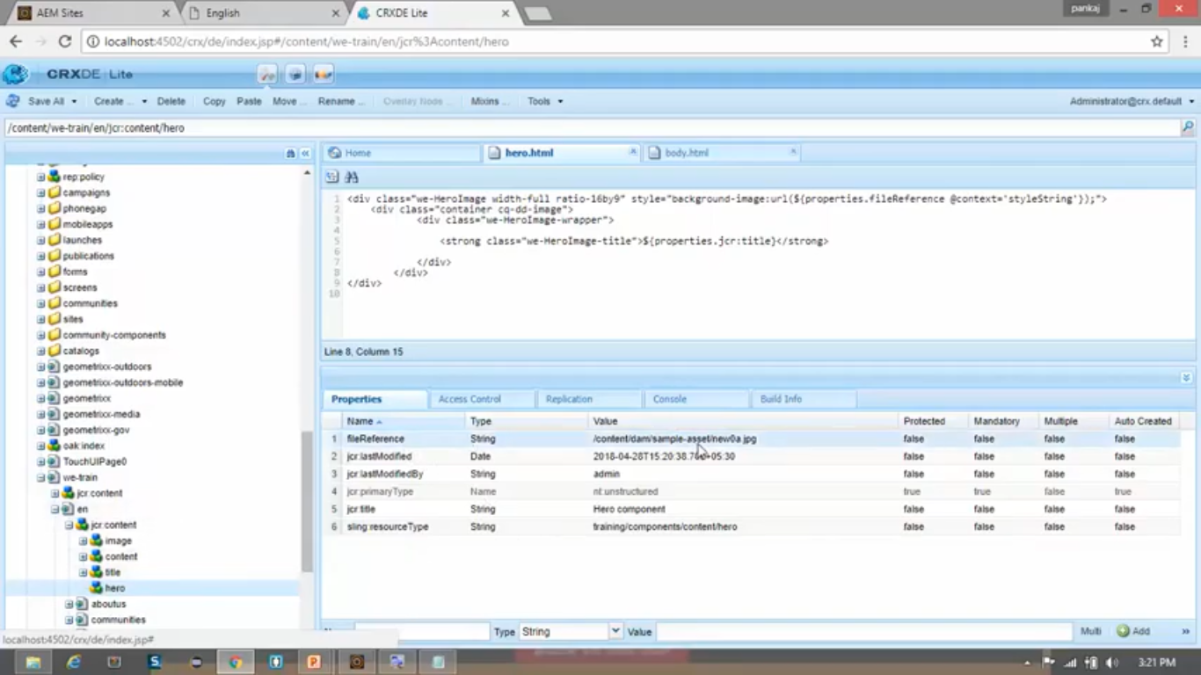

1. With this you can **edit** Hero component in any page from current website **We-Train**.

# 49. editConfig (drag and drop functionality)

1. In last section, we had to click on **Edit** icon, open dialog box and then select **image** for Hero component.
2. In this section, we will **implement drag and drop** image functionality by doing change editConfig file.
3. So, there will be no need to open dialog box to change image of Hero component.
4. Author can directly drag and drop image over Hero component.
5. We can do it by **creating** **editConfig** from scratch.
6. **Delete** node <apps/training/components/content/hero/cq:editConfig>. Click on **Save All** button.
7. Right click on node <apps/training/components/content/hero> --> **Create** --> Create **Node** -->



1. Right click on <apps/training/components/content/hero/cq:editConfig> --> **Create** --> **Create Node** -->

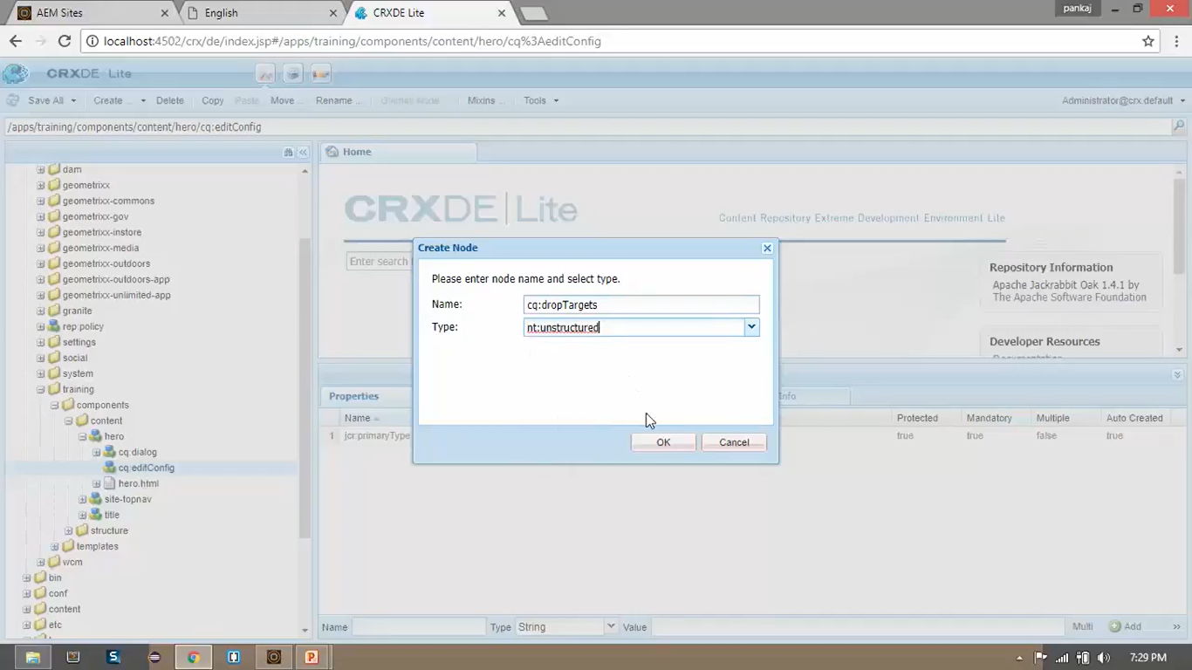

1. Right click on <apps/training/components/content/hero/cq:editConfig/cq:dropTargets> --> Create --> Create **Node** -->

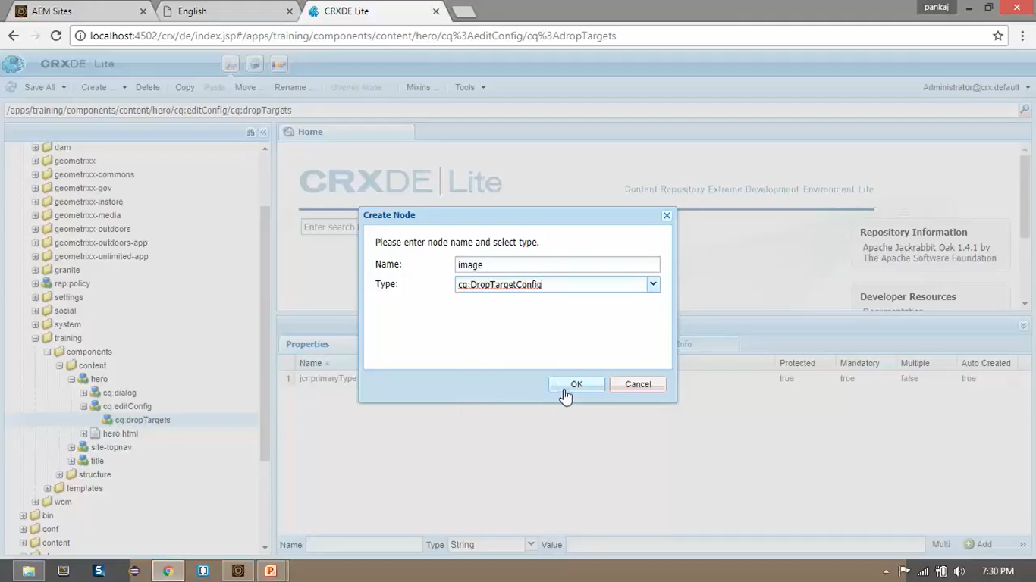

1. Add below **properties** from Properties Pane:

|  |  |  |  |
| --- | --- | --- | --- |
| **Field Name** | **Type** | **Value** | **Action** |
| accept | String | image/\* | Click “Multi” button |
| groups | String | media | Click “Multi” button |
| propertyName | String | /fileReference | <NO ACTION> |

1. Right click on [apps/training/components/content/hero/ cq:editConfig/cq:dropTargets/image](apps/training/components/content/hero/%20cq:editConfig/cq:dropTargets/image)

--> **Create** --> Create **Node** -->

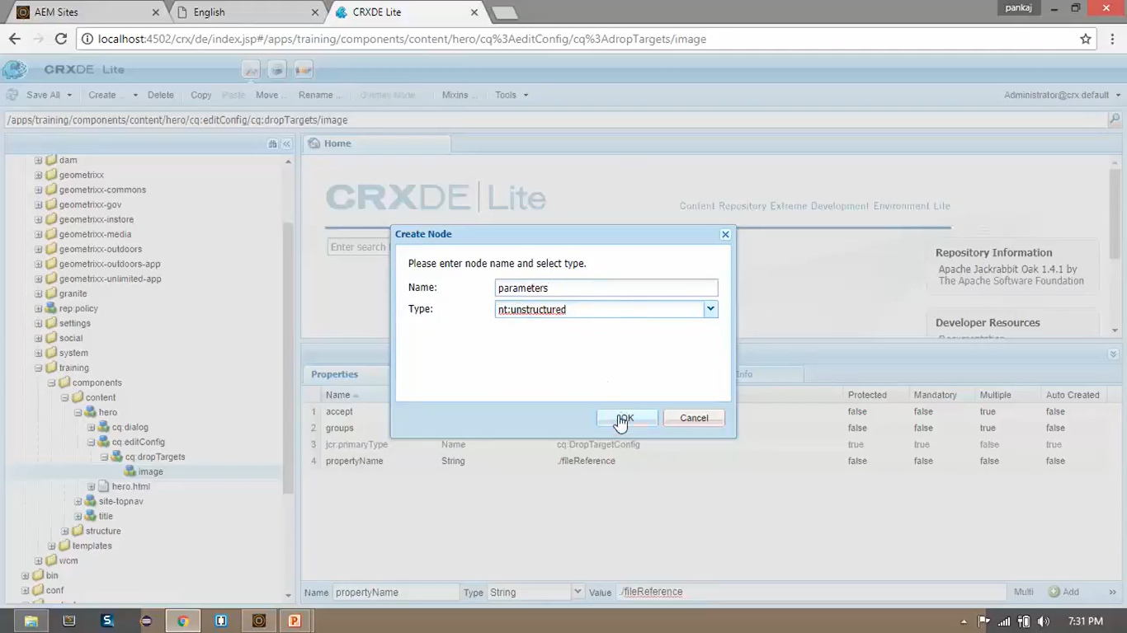

1. Right click on [apps/training/components/content/hero/ cq:editConfig/cq:dropTargets/image](apps/training/components/content/hero/%20cq:editConfig/cq:dropTargets/image)
2. **Add** below **properties** from Properties Pane:

|  |  |  |
| --- | --- | --- |
| **Field Name** | **Type** | **Value** |
| Sling:resourceType | String | Training/components/content/hero |
| groups | String | media |
| propertyName | String | /fileReference |

1. Click on **Save** All button.
2. We are done. You can test **Drag and Drop** functionality.

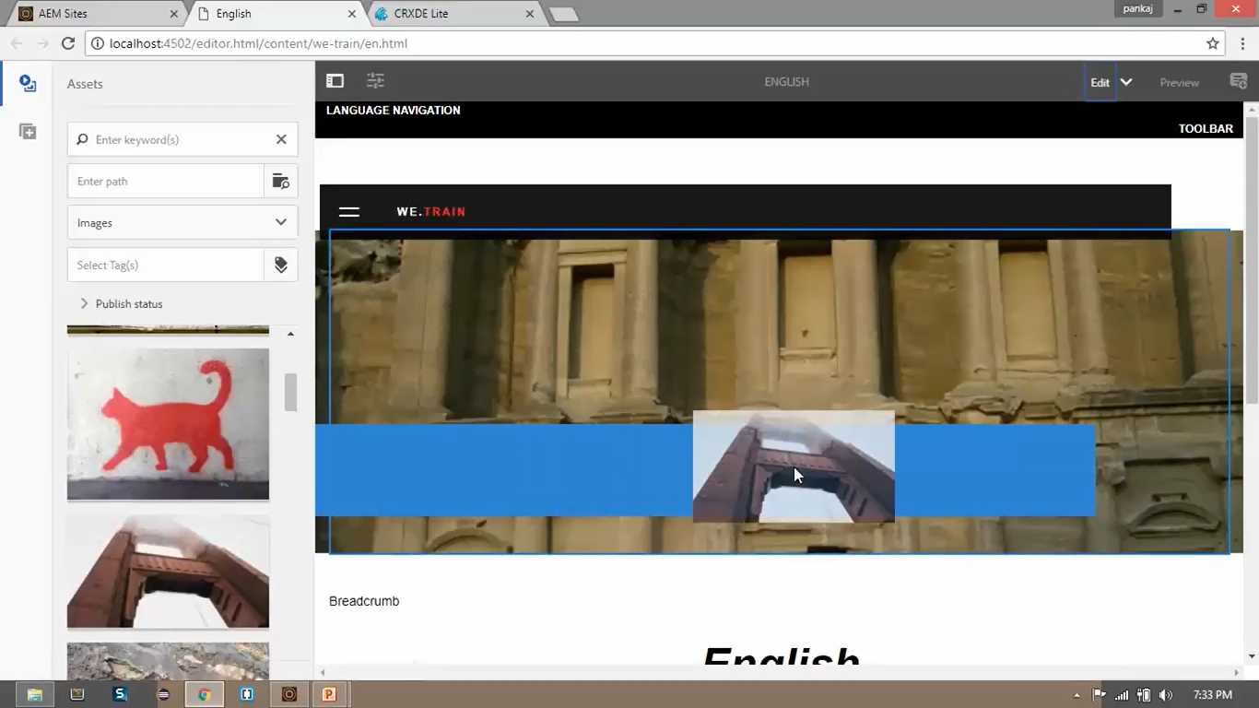

# 50. Internationalization (i18n) – Part 1

1. There are 18 characters in spelling. Hence, it is also called as **i18n**.
2. Suppose we want to **create** a **website** to display text based on country. For e.g., if a person is accessing a site from **France**, then page should display text in **French**. To achieve this, we use **Internationalization**.

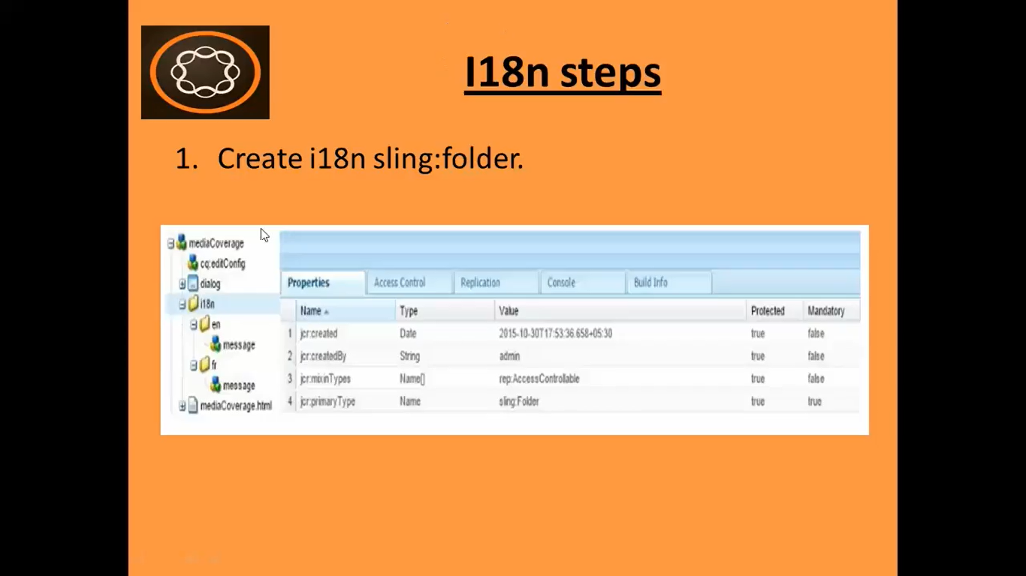

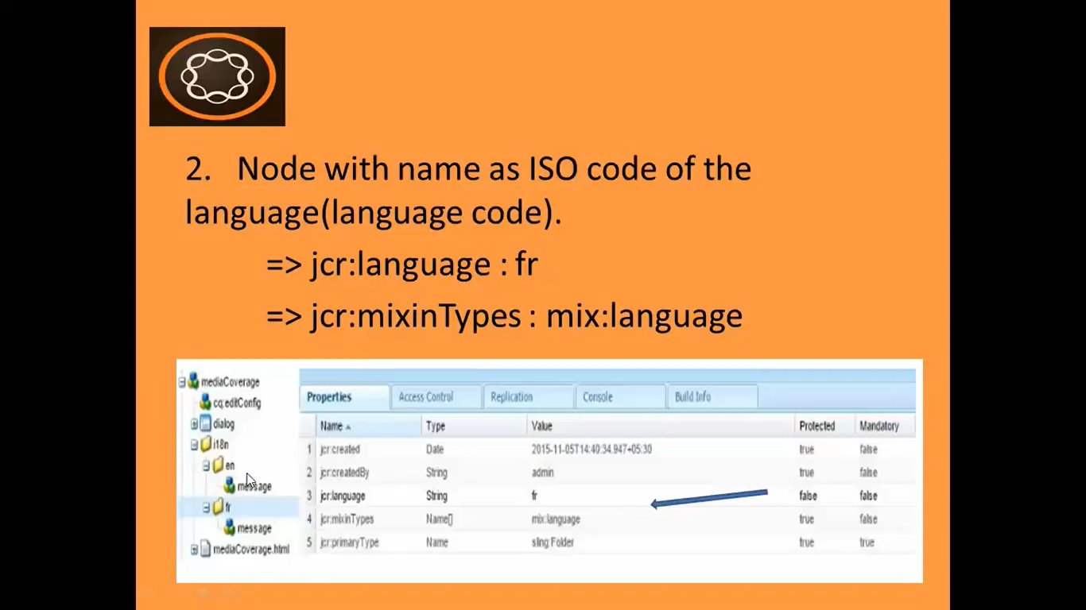

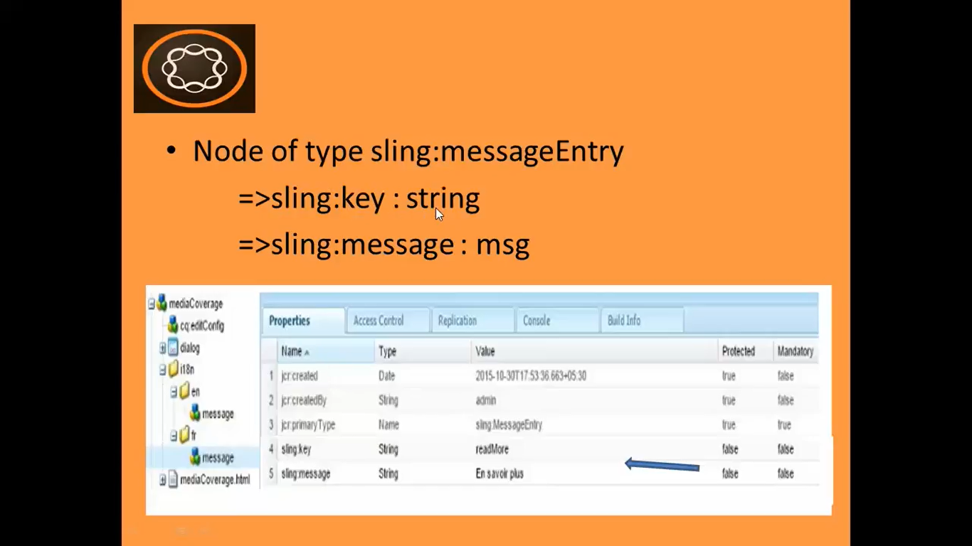

# 51. Internationalization (i18n) – Part 2

1. In this section, we will exercise to internationalize to copyrights statement on footer of the website.
2. Go to **AEM** --> **Sites** --> **We.Train** --> Click **Create** Button --> select **Page** option --> select **Page Template** named **We.Train Content page** --> Enter below field values:

|  |  |
| --- | --- |
| **Field Name** | **Field Value** |
| Name | de |
| Title | German |

1. **Right click** on **CRX/DE** node </apps/training/components/structure/contentpage> --> **Create** --> Create **Folder** --> Set folder Name as **i18n** --> **OK** button --> **Save All** button

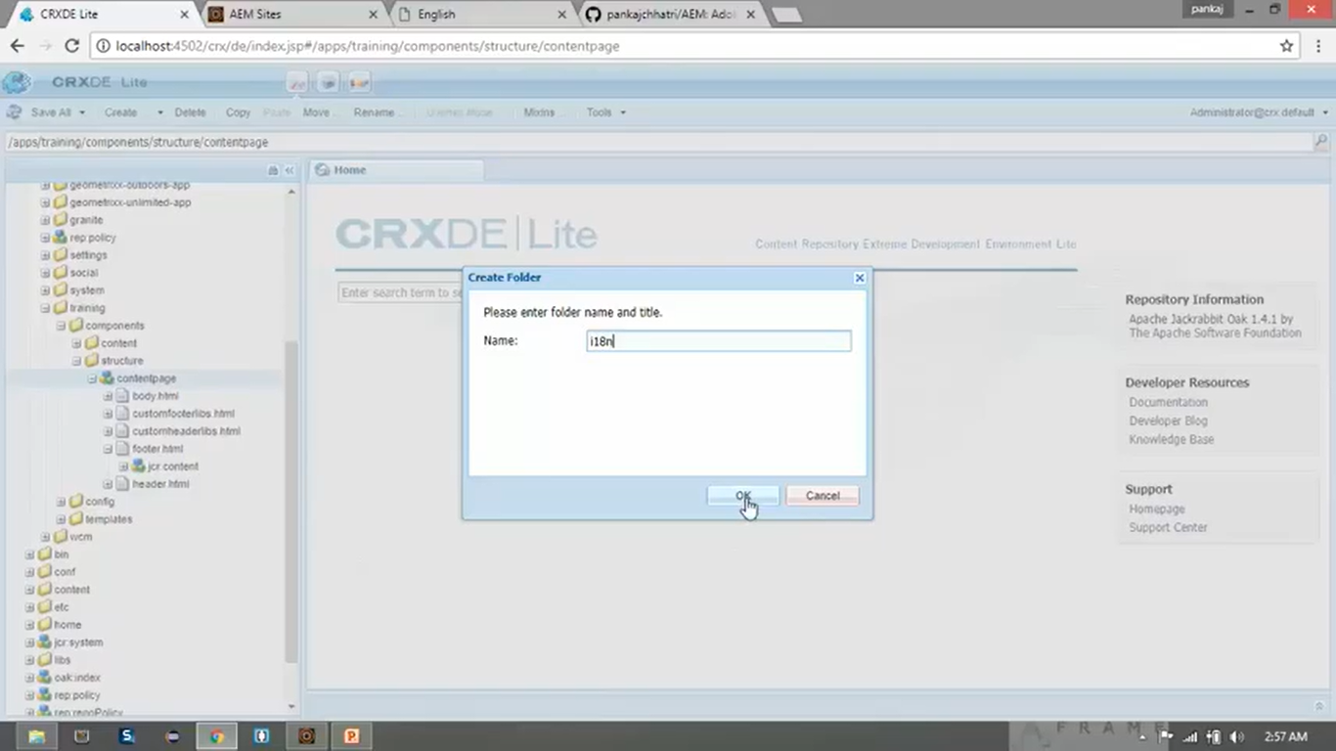

1. **Right click** on **CRX/DE** node </apps/training/components/structure/contentpage/i18n> --> **Create** --> Create **Folder** --> Set folder Name as **en**

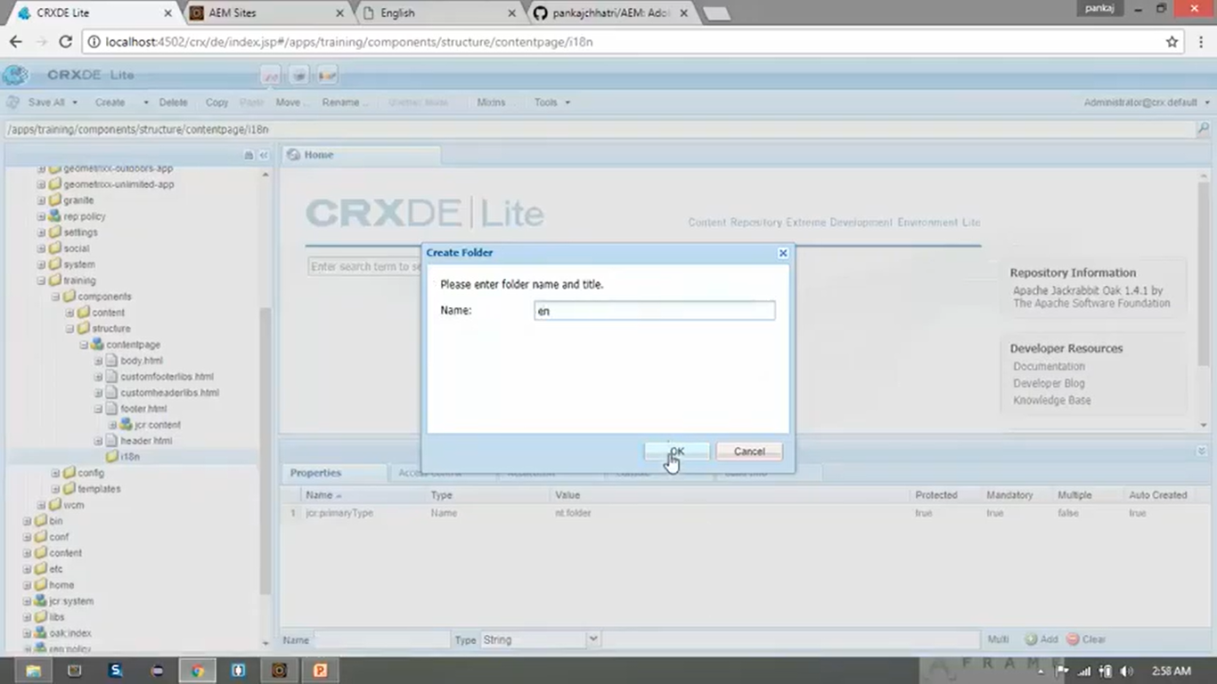

1. Just **Click** on **newly created** node </apps/training/components/structure/contentpage/i18n/en> --> **Click** on **Mixins** button from Toolbar.

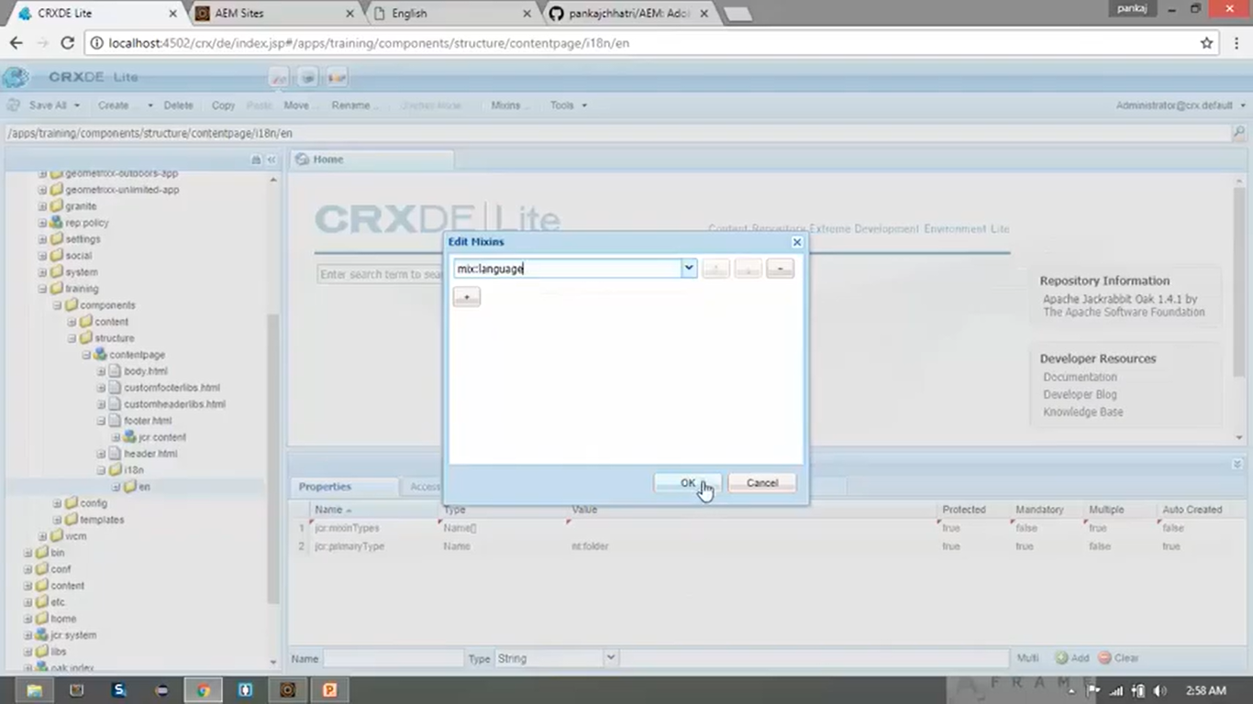

1. **Add property** from Properties Pane to this same node “**en**”

|  |  |  |
| --- | --- | --- |
| **Field Name** | **Field Type** | **Field Value** |
| Jcr:language | String | en |

1. **Right click** on same node “**en**” --> **Create** --> Create **Node**

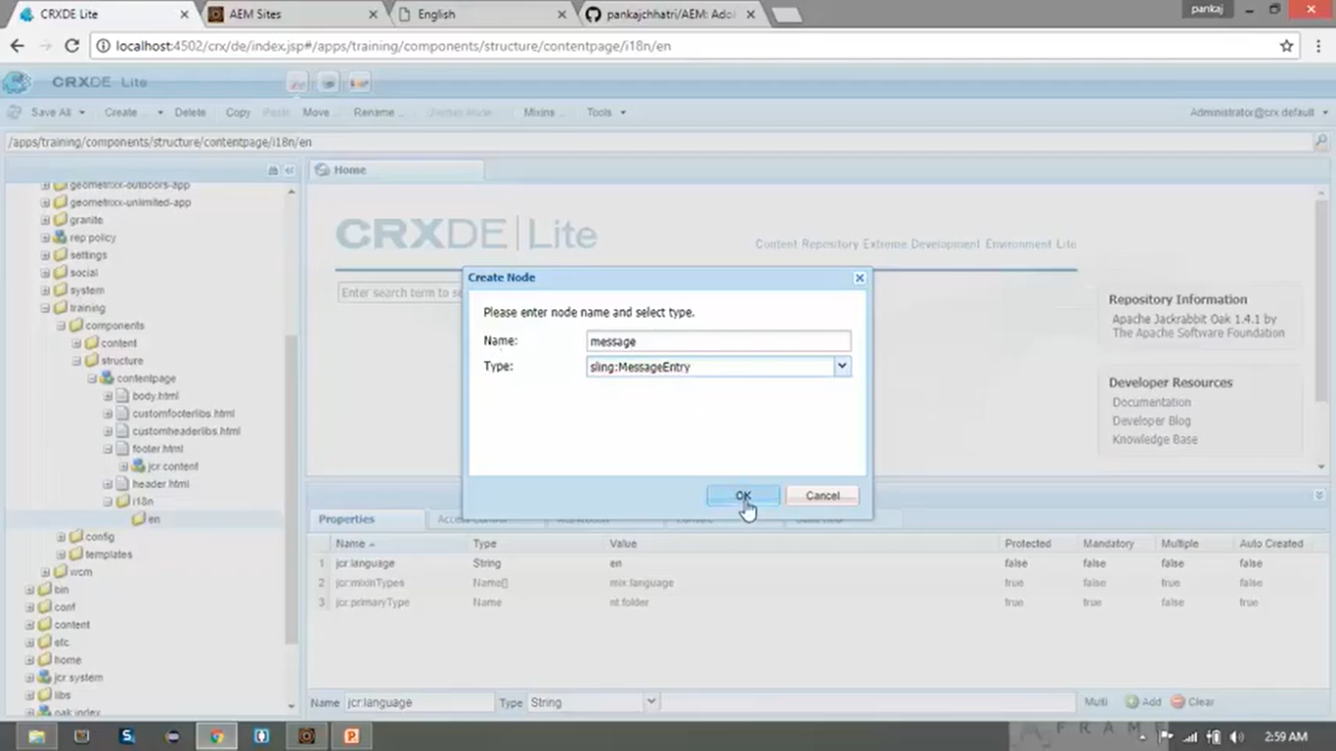

1. **Add properties** from Properties Pane to same node “**message**”

|  |  |  |
| --- | --- | --- |
| **Field Name** | **Field Type** | **Field Value** |
| sling:key | String | copy |
| Sling:message | String | This is the copyright statement |

1. **Copy** newly created node **en**. **Paste** (2 times) inside node **i18n**. **Name** these 2 nodes as **fr** and **de**.
2. **Change** the **properties** of respective **folders** with below values:

|  |  |  |  |
| --- | --- | --- | --- |
| **Field Name** | **Field Type** | **Field Value (node fr)** | **Field Value (node de)** |
| Jcr:language | String | fr | de |

1. **Change** the **properties** from properties pane of node **message** for nodes **fr** and **de**

|  |  |  |  |
| --- | --- | --- | --- |
| **Field Name** | **Field Type** | **Field Value (for fr node)** | **Field Value (for de node)** |
| Sling:message | String | Ceci est la déclaration de copyright | Dies ist die Copyright-Erklärung |

1. Click on **Save All** button from toolbar.
2. **Open** the **CRX/DE file** named </apps/training/components/structure/contentpage/footer.html>.
3. **Delete** all the **file contents**.
4. Go to [Developer course](https://github.com/pankajchhatri/AEM/tree/master/Developer%20course/Chapter%2010%20Authoring%20Structure%20Components/Lab%20Activity%20-%20I/Task%201%20-%20Create%20a%20simple%20navigation%20component) --> [Chapter 12 Internationalization](https://github.com/pankajchhatri/AEM/tree/master/Developer%20course/Chapter%2012%20Internationalization) --> [Task 2 - Create content to be localized](https://github.com/pankajchhatri/AEM/tree/master/Developer%20course/Chapter%2012%20Internationalization/Task%202%20-%20Create%20content%20to%20be%20localized)
5. **Copy** contents of **footer.html** into our **footer.html** --> **Click** on **Save All** button.
6. The **new file content** is **same** as old file content **except one highlighted change** at line number 18

<span class="text-uppercase text-muted">${"**copy**" @ **i18n**, context='html'}</span>

**Open** below **URLs** in browser to **check** the **footer text** is shown as per page languages.

1. <http://localhost:4502/content/we-train/en.html>
2. <http://localhost:4502/content/we-train/fr.html>
3. <http://localhost:4502/content/we-train/de.html>

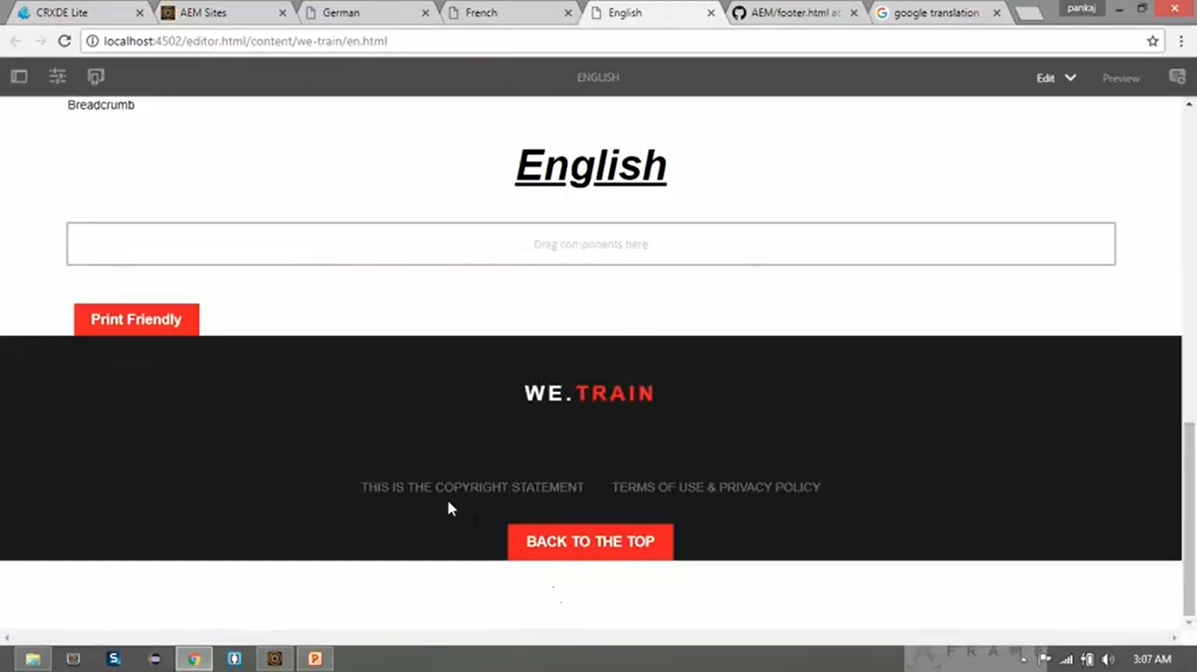

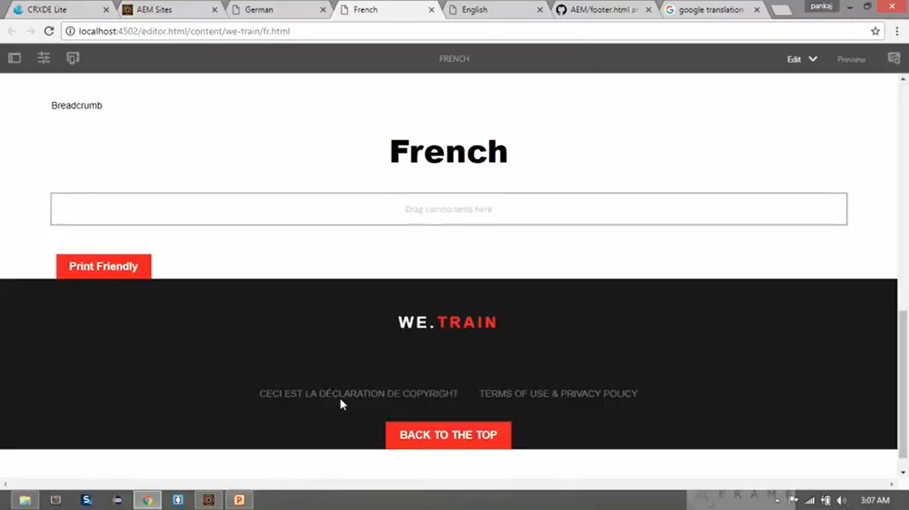

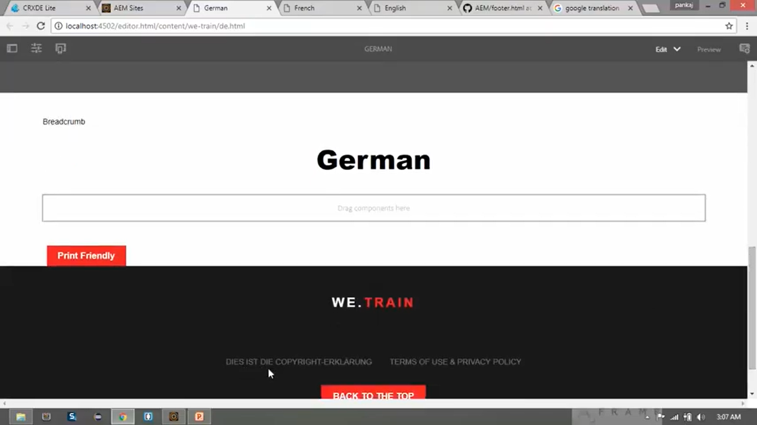

# 52. Internationalization in Touch dialog box in AEM

1. In this section, we will learn how can **change** the **language** of the **text** using **Touch** **Dialog Box**.
2. Suppose we want to show the **text** of **Title** field from below **Hero Component’s** **Dialog Box** in respective **languages** (English, French or German).
3. We can **achieve** this using Internationalization **i18n** using **below steps**.

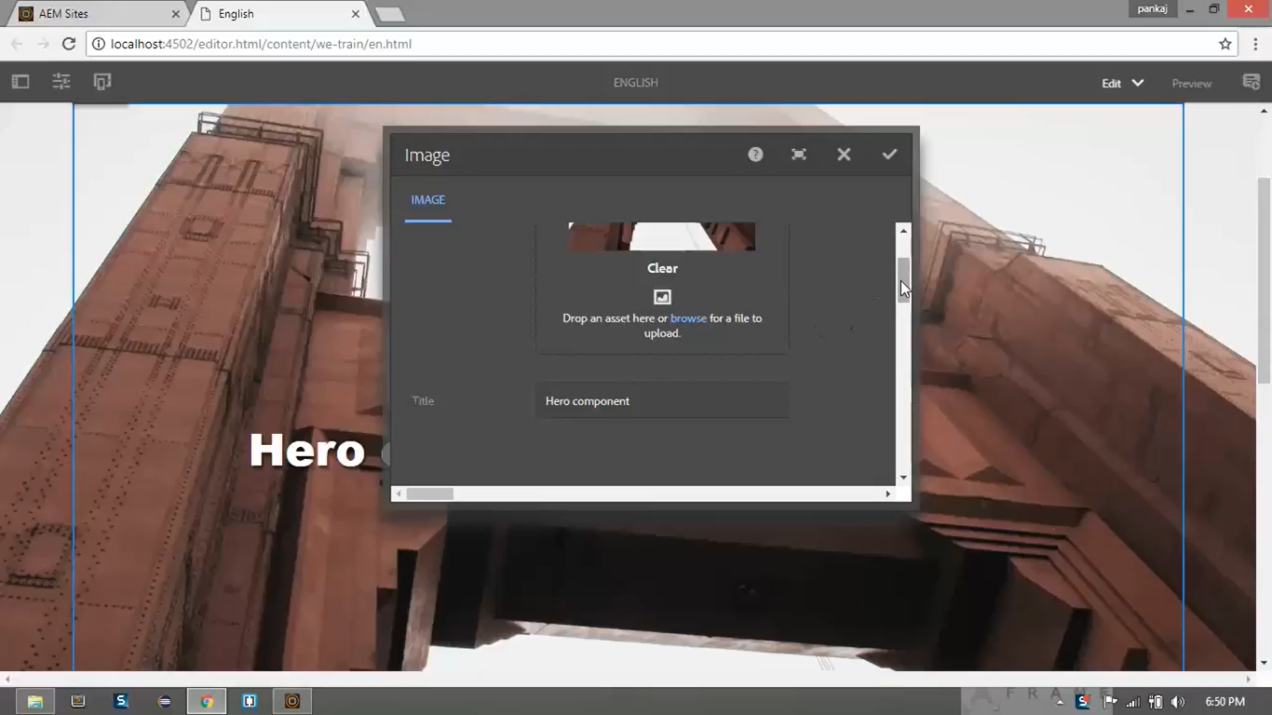

1. **Right click** on **CRX/DE** node </apps/training/components/content/hero> --> **Create** --> Create **Folder** --> Name it **i18n** folder



1. Click on **Save All** button.
2. **Right click** on **CRX/DE** node </apps/training/components/structure/contentpage/i18n> --> **Create** --> Create **Folder** --> Set Name as **en**



1. Just **Click** on **CRX/DE** node </apps/training/components/structure/contentpage/i18n/en> --> Click on **Mixins** button from **Toolbar** section.



1. **Add property** from Properties Pane to same node **en**

|  |  |  |
| --- | --- | --- |
| **Field Name** | **Field Type** | **Field Value** |
| Jcr:language | String | en |

1. **Right click** on same node **en** --> **Create** --> Create **Node** --> **Name** it as **hero.image**

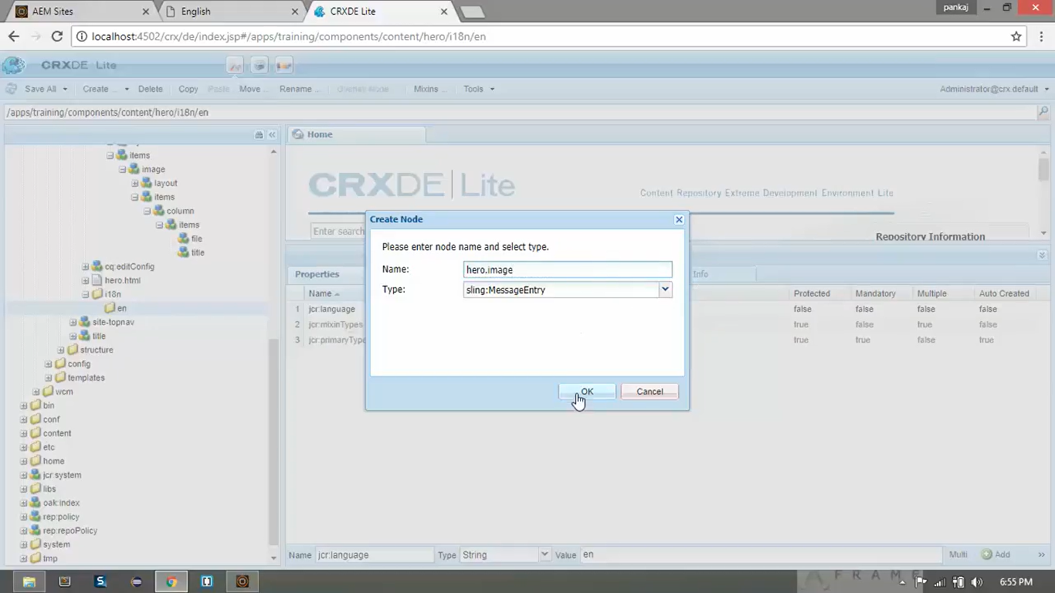

1. **Add properties** from Properties Pane to same node **hero.image**

|  |  |  |
| --- | --- | --- |
| **Field Name** | **Field Type** | **Field Value** |
| Sling:message | String | Image Asset |

1. Right click on same node “**en**” --> Create --> Create Node “**hero.title**”

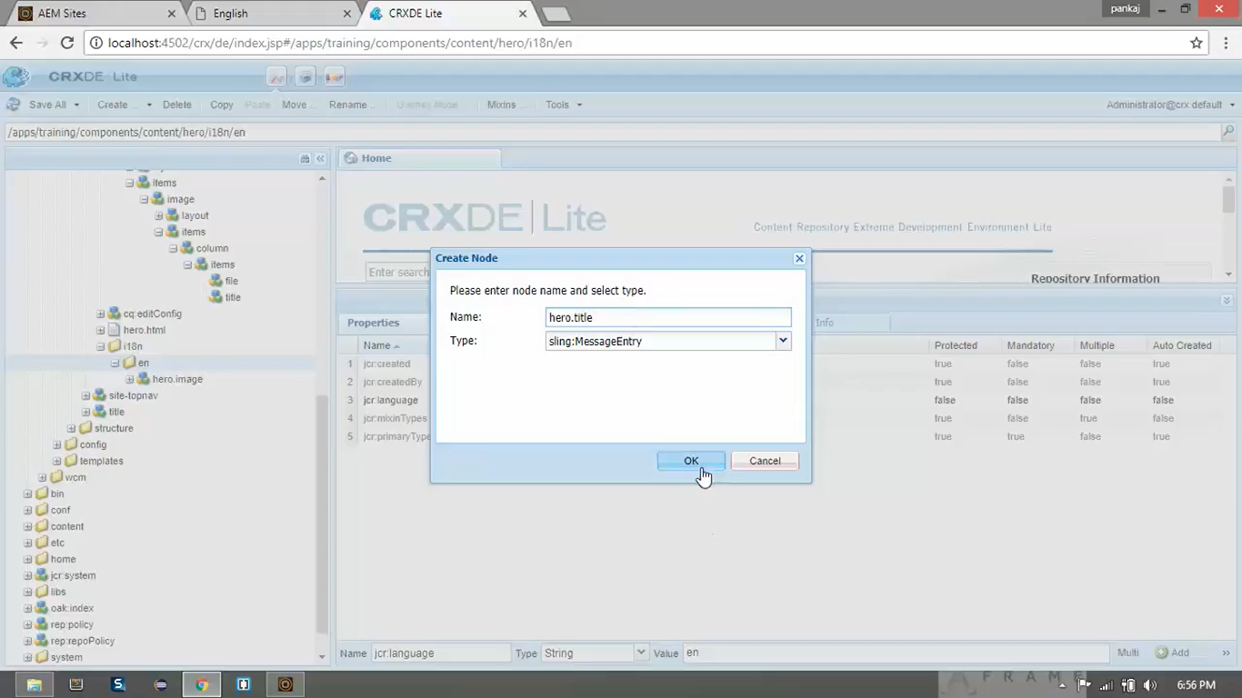

1. Add properties from **properties** pane to same node “**hero.title**”

|  |  |  |
| --- | --- | --- |
| **Field Name** | **Field Type** | **Field Value** |
| Sling:message | String | Title |

1. **Copy** newly created node **en**. **Paste** (2 times) inside node **i18n**. **Name** these 2 nodes as **fr** and **de**.
2. **Change** the **properties** of respective folders with below values:

|  |  |  |  |
| --- | --- | --- | --- |
| **Field Name** | **Field Type** | **Field Value (node fr)** | **Field Value (node de)** |
| Jcr:language | String | Fr | De |

1. **Change** the **properties** from Properties Pane of node **hero.image** for nodes **fr** and **de**

|  |  |  |  |
| --- | --- | --- | --- |
| **Field Name** | **Field Type** | **Field Value (for fr node)** | **Field Value (for de node)** |
| Sling:message | String | Élément d'image | Bildasset |

1. **Change** the **properties** from Properties Pane of node **hero.title** for nodes **fr** and **de**

|  |  |  |  |
| --- | --- | --- | --- |
| **Field Name** | **Field Type** | **Field Value (for fr node)** | **Field Value (for de node)** |
| Sling:message | String | Titre | Titel |

1. Click on **Save All** button from toolbar.
2. **Open** the **CRX/DE file** [/apps/training/components/content/hero/cq:dialog/content/items/image/items/column/items/file](1)%09/apps/training/components/content/hero/cq:dialog/content/items/image/items/column/items/file)
3. **Change** the **property** from Properties Pane of this node “**file**”

|  |  |  |  |
| --- | --- | --- | --- |
| **Field Name** | **Field Type** | **Old Value** | **Field Value** |
| fieldLabel | String | Image | hero.image |

1. **Open** the **CRX/DE file** </apps/training/components/content/hero/cq:dialog/content/items/image/items/column/items/title>
2. **Change** the **property** from Properties Pane of this node “**title**”

|  |  |  |  |
| --- | --- | --- | --- |
| **Field Name** | **Field Type** | **Old Value** | **Field Value** |
| fieldLabel | String | Title | hero.title |

1. Go to <http://localhost:4502/useradmin> Search “**admin**” in search box.
2. Select 1st option named “**admin**”

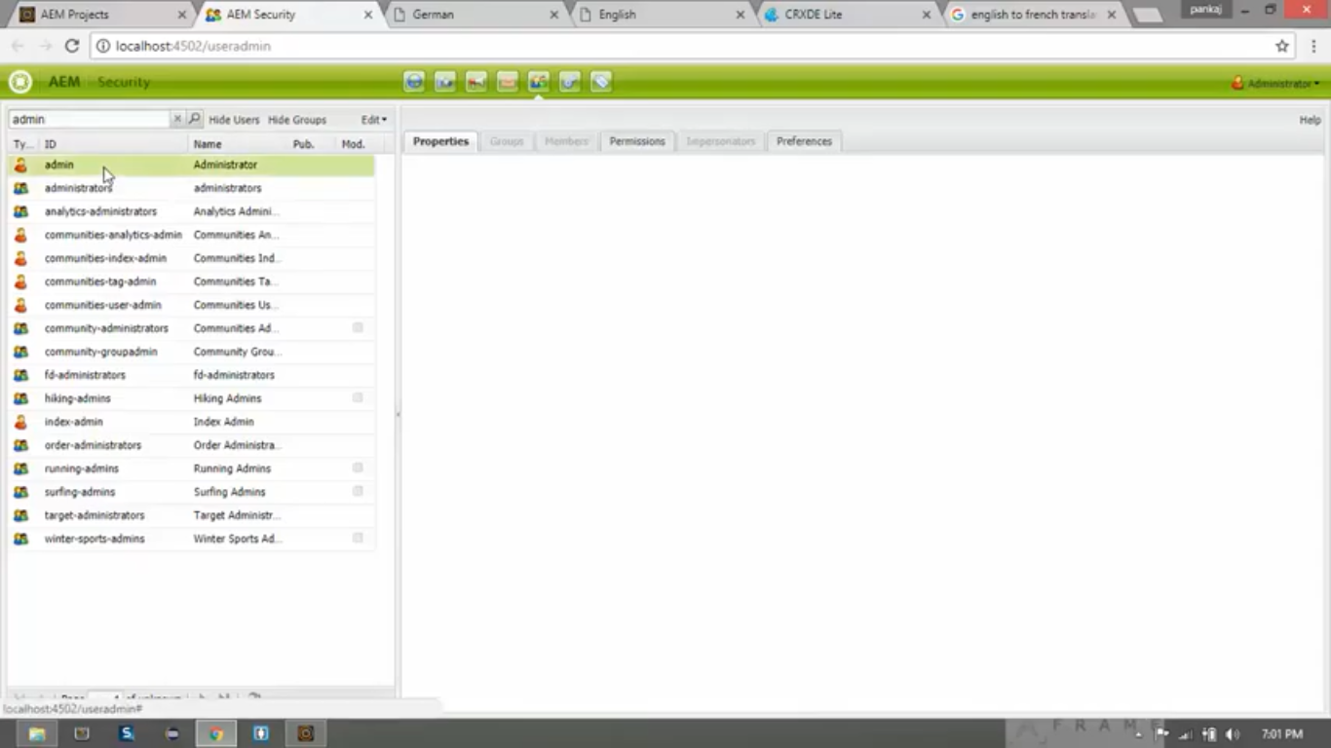

1. Go to **Preferences** tab. Set **Language** field to **German**.

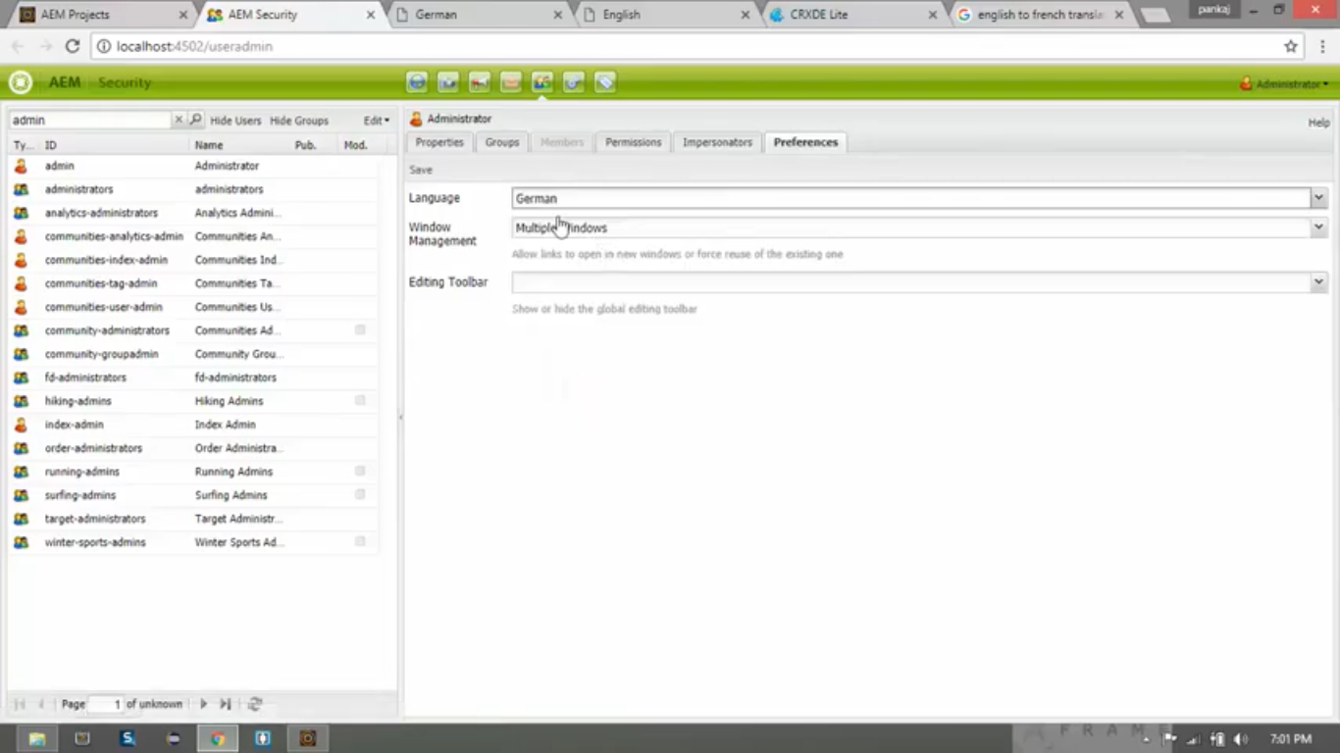

1. Open the **Page URL** <http://localhost:4502/content/we-train/de.html>
2. You can see that **changes** has been **reflected** and you can see the **text** in **German** language.

